https://epubs.icar.org.in/index.php/IJSS  InternationalJournalofSeedSpices(IJSS)  Vol.16(1)June,2026 | 

Efficacyofbio-controlagentsagainstFusariumoxysporum f.sp.cuminicausing wilt in cumin (Cuminum cyminum L.)

*B.K.Prajapati1and N.R.Patel2

Reviewedby:  Dr.J.R.Pandya  CollegeofAgriculture,Bharuch Navsari Agricultural University Gujarat, India  Email:jrpandya@nau.in  *Correspondence:  B.K. Prajapati  b.prajapati@sdau.edu.in  Received:17June 2026  Revision:22July2026  Accepted:01October2026  Citation  Prajapati, B.K., & Patel, N.R., (2026) Efficacy of bio-control agents against Fusarium oxysporum f. sp. cumini causing wilt in cumin (Cuminum cyminum L.). Int J Seed Spice.16 (1): 51-59  DOI:  https://doi.org/10.56093/IJSS.v16i1.6  Affiliations  ¹Department of Plant Protection, CollegeofHorticulture,Jagudan,Dist. Mehsana, Gujarat, India  ²Seed Spices Research Station, S. D. AgriculturalUniversity,Jagudan,Dist.  Mehsana,Gujarat,India | Abstract  Atwo-yearfieldinvestigation(2022–24)wasconductedtoevaluatethe efficacy of different bio-control agents in managing cumin wilt caused by Fusarium oxysporum f. sp. cumini. Six treatments, including soil applications of farmyard manure (FYM) enriched with Trichoderma harzianum, T. viride, other microbial antagonists, and a control, were assessed for wilt incidence at 30, 45, and 60 days after sowing (DAS). Among the treatments, FYM enriched with T. harzianum (T2) consistently recorded the lowest disease incidence at all stages in both years, with the greatest reduction (up to 70.69%) compared with the untreatedcontrol(T6).Similarly, T.viride(T1)wasalsoeffective,with asubstantialreductionindiseaseincidence.PooleddatashowedthatT2 and T1 achieved the lowest mean wilt incidence (11.46% and 14.23%, respectively). Area Under Disease Progress Curve (AUDPC) values further confirmed the superior performance of T. harzianum and T. viride in both seasons. Seed yield significantly improved under these treatments, with pooled yields of 6.54 q/ha (T2) and 6.24 q/ha (T1), compared to 2.39 q/ha in the control. No significant differences were observed among treatments for volatile oil content and 1000-seed weight.Theresultshighlightthepotentialof T.harzianumandT.viride aseffective,eco-friendlybiocontrolagentsforsustainable management of cumin wilt and enhanced crop productivity.  Keywords:Trichodermaharzianum,Trichodermaviride,Fusarium wilt, cumin, bio-control

Introduction
Cumin(CuminumcyminumL.)isahigh-valueseedspice cultivated predominantly in arid and semi-arid regions, with India contributing nearly 70 per cent of global production and trade (Jadon et al., 2025). Cumin is a commercially important spice crop of the Apiaceae family, widely valued for its culinary, aromatic, and medicinalproperties.Cultivatedpredominantlyduring
the Rabi season, it thrives in dry, cool climates, making the arid and semi-arid regions of Gujarat and Rajasthan ideal for production (Didwania, 2019). Gujarat recorded thehighestproductionof518MTfrom5.30lakhhectares during 2023-24, while Rajasthan leads in cultivated area (Anonymous, 2024). Cumin productivity is frequently constrained by biotic stresses, particularly diseases and insectpests.Amongthem,Fusariumwiltcausedby

2278-8417/©2026 ISSS 52

Fusarium oxysporum f. sp. cumini is the most devastating,withthepotentialtocauseyieldlossesofup to 80per cent (Dar et al., 2019).The disease is favoured by specific soil and environmental conditions and is widespread in major cumin-growing regions. Over time, new pathogenic races have emerged, compromising the durability of wilt-resistant cultivars and reducing their effectiveness. Chemical fungicides, though widely used, pose environmental and economic challenges, including soilandwatercontamination,resistancedevelopmentand higher input costs. Hence, there is growing interest in sustainable, eco-friendly management strategies. Recent studies have highlighted the potential of microbial bioagents such as Trichoderma, Bacillus and Pseudomonas for the sustainable management of soil-borne plant pathogens. These microorganisms suppress Fusarium spp. through competition for nutrients and space, mycoparasitism, antibiosis, siderophore productionandsecretionofcellwalldegradingenzymes. Trichoderma spp. can directly parasitize fungal pathogens and produce hydrolytic enzymes and antifungal metabolites, while Bacillus spp. produce antimicrobial lipopeptides and other secondary metabolites that inhibit pathogen growth. Pseudomonas spp. contribute through siderophore production, antibiosis and induction of plant defence responses (Singh et al., 2025). Bioagents may also promote plant growth and enhance induced systemic resistance, improving plant defence against infection. Given these considerations, this study evaluated the impact of different bio-control agents on cumin wilt incidence, aiming to identify sustainable alternatives to chemical control measures.

Materialsandmethods
A two-year field study was conducted during the Rabi seasonsof2022-23and2023-24toevaluatetheimpactof variousbiologicalcontrolagentsoncumin wiltincidence, caused by Fusarium oxysporum f. sp. cumini. The experiment was conducted with the cultivar Gujarat Cumin4(GC4)underopen-fieldconditions.The
experimentcomprised sixtreatments:T₁-soilapplication of farmyard manure (FYM) enriched with Trichoderma viride 1.50 WP at 1 kg per 100 kg FYM; T₂-FYM enriched with T. harzianum 1.50 WP at 1 kg per 100 kg FYM;T₃-FYMenrichedwithT.atrovirideat1kgper100 kg FYM; T₄-FYM enriched with Pseudomonas fluorescens 1.75 WP at 1 kg per 100 kg FYM; T₅-FYM enriched with Bacillus subtilis 2.0 AS at 1 L per 100 kg FYM; and T₆-untreated control.
The trial was arranged in a Randomized Block Design (RBD) with six treatments and four replications. Each grossplotmeasured3.0m×4.0m,withanetplotsizeof
2.4 m × 3.0 m, and an inter-row spacing of 30 cm was maintainedthroughout.Thisexperimentallayoutenabled uniform application of treatments and effective assessment of disease incidence under field conditions. The study aimed to assess the efficacy of these organic inputs in reducing wilt incidence while promoting sustainable disease management in cumin cultivation.

Observationsrecorded:
- Per cent disease incidence assessed at 30, 45, and 60 daysaftersowingfromthreerandomlyselectedspots (1 m row length each) per plot
- Area Under Disease Progress Curve (AUDPC) for wilt incidence
- Seedyield(q/ha)
- Volatileoilcontent(%)
- 1000-seedweight(g)
For volatile oil (%) analysis of cumin seeds, steam distillation method was used as described by Guenther (1972) and followed by Singh et al. (2006).
The Area Under Disease Progress Curve (AUDPC) was calculated to evaluate the effect of various treatments against cumin wilt disease incidence as per the below-mentioned method suggested by Shaner and Finney (1977):
AUDPC=i=1∑n−1[2(Yi+Yi+1)×(Ti+1−Ti)]
Where:

Yi=Diseaseincidence(%)atthei^{th}observation
Yi+1=Diseaseincidence(%)atthe(i+1)^{th}observation Ti = Time (days after sowing) at the i^{th}observation Ti+1 = Time at the (i+1)^{th}observation
n =Numberof observations

Results and discussion Percentdiseaseincidence
Year2022-23
During the first year of experimentation (2022–23), the effect of six different bio-control treatments on cumin wilt incidence was recorded at 30, 45, and 60 days after sowing (DAS), along with pooled observations. The resultsrevealedsignificantdifferencesamong treatments.

At30DAS
Minimum wilt incidence (4.17%) was observed in treatment T2(soil application of farm yard manure enriched with Trichoderma harzianum 1.50 WP @ 1 kg/100 kg FYM). This was statistically at par with T1(FYM enriched with T. viride, 5.08%) and significantly lower than the untreated control (T6), which recorded 24.94% disease incidence.

At45DAS
Treatment 2 continued to exhibit the least disease incidence(11.24%),remainingstatisticallyatparwithT1(14.52%), whereas the control recorded a significantly higher disease incidence of 32.00 per cent.

At60DAS
TreatmentT2recordedthelowestwiltincidenceof16.56 per cent, which was again statistically at par with T1(20.75%) and significantly superior to the control (46.84%).

Reductionovercontrol
The highest reduction over control in per cent disease incidence at 60 DAS was observed in T2(64.65%) followed by T1 (55.70%).Overall, soil application of FYM enriched with T. harzianum (T2)and T. viride (T1) proved to be the most effective in reducing cumin wilt incidence as compared to other treatments and the control.

Year2023-24
During the second year of experimentation (2023–24), theeffectofsixdifferentbio-controltreatmentsoncumin wilt incidence was recorded at 30, 45, and 60 days after sowing (DAS), along with pooled observations. The results showed significant differences among treatments in controlling cumin wilt disease.

At30DAS
Minimum wilt incidence was observed in treatment T2(soil application of farmyard manure enriched with Trichodermaharzianum1.50WP@1kg/100kgFYM), recording 5.08 per cent disease incidence. This was statisticallyatparwithT1(soilapplicationofFYM
enriched with T. viride, 6.08%) and significantly lower than the untreated control (T6), which recorded a high disease incidence of 33.30 per cent.

At45DAS
Treatment T2again showed the lowest wilt incidence (15.48%),remainingstatisticallyatparwithT1(17.68%), whiletheuntreatedcontrolrecordedthehighestincidence (45.83%).

At60DAS
Treatment 2 continued to perform best with a disease incidence of 15.58 per cent, statistically at par with T1(20.68%) and significantly superior to the control (53.16%).

Reductionovercontrol
The highest reduction over control in per cent disease incidence at 60 DAS was observed in T2(70.69%) followed by T1 (61.10%).Overall, soil application of FYM enriched with Trichoderma harzianum (T2) and T. viride (T1) consistently proved to be the most effective treatmentsinreducingcuminwiltincidenceascompared to other treatments and the untreated control during the second year.

Pooledoveryeardata
Pooled results over two years (2022–23 and 2023–24) showed a consistent trend of reduced cumin wilt incidence with the application of bio-control agents. Among all treatments, soil application of farm yard manure enriched with Trichoderma harzianum (T2) was foundtobethemosteffective,recordingthelowestmean disease incidence (11.46%), followed by T. viride (T1) with 14.23%. In contrast, the untreated control (T6) recorded the highest disease incidence (39.41%).
TheconsistentsuperiorperformanceofT.harzianumand
T. viride can be attributed to their strong antagonistic properties against soil-borne pathogens like Fusarium oxysporum f. sp. cumini, the causal agent of cumin wilt. These bio-control agents not only suppress the pathogen population in the rhizosphere through competition and mycoparasitism but also enhance plant health by promotingrootgrowthandinducingsystemicresistance.

Thus, it can be concluded that soil application of farm yardmanureenrichedwithTrichodermaharzianumorT. viride before sowing is an effective, eco-friendly and sustainable approach for managing cumin wilt disease and can be recommended for integrated disease management practices in cumin cultivation.

AUDPC study of different bio-control agents on cumin wilt disease (2022-23)
The effect of different bio-control agents on cumin wilt disease incidence was evaluated through AUDPC analysis during the first year (2022-23). The lowest average AUDPC value (328.14) was recorded in the treatmentinvolvingFYM+Trichodermaharzianumsoil application, indicating its superior efficacy in reducing disease progression. This was followed by the treatment with FYM + Trichoderma viride soil application, which recorded an AUDPC value of 414.09. In contrast, the untreated control showed the highest AUDPC value (1023.45), highlighting the significant impact of bio-control agents in mitigating cumin wilt disease.

AUDPC study of different bio-control agents on cumin wilt disease (2023-24)
The Area Under Disease Progress Curve (AUDPC) analysis for the effect of different bio-control agents on cumin wilt disease incidence during the second year (2023-24) revealed significant differences among treatments. The lowest average AUDPC value of390.66 was recorded in the FYM + Trichoderma harzianum treatment, indicating the highest efficacy in disease suppression. This was followed byFYM + Trichoderma viride, which exhibited an AUDPC value of 468.79. In contrast, the untreated control plot showed the highest AUDPC value of 1335.90, reflecting the severe disease progression in the absence of bio-control intervention.

Effect of different treatments on volatile oil of cumin seeds
The volatile oil percentage observed under field conditions in both years (2022-23 and 2023-24) showed no significant difference among the cbio-control treatments.Thevolatileoilpercentage forboththe years ranged from 4.41 to 4.54 per cent across all treatments, including the control. Healthy seeds from all treatments were selected for the volatile oil analysis to ensure consistency and accuracy in the results. This outcome suggeststhatthegeneticfactorsoftheGC4variety,
whichmayplayadominantroleinvolatileoilproduction, likely influenced oil content.

Effect of different treatments on 1000 seed weight of cumin seeds
Theresultsforthe1000seedweightobservedunderfield conditions in both years (2022-23 and 2023-24) showed no significant difference among the various bio-control treatments.The1000-seedweightrangedfrom 4.24gto
4.37 g across all treatments, including the control. Healthy seeds from all treatments were selected for the studyof1000-seedweight,andthusitmighthaveshown a non-significant result.

Effectofdifferenttreatmentsoncuminyield
The impact of different bio-control agents on the seed yield of cumin was thoroughly evaluated over two consecutiveyears(2022-23and2023-24),andtheresults consistently demonstrated the superiority of certain treatments.

Year2022-23
Among the six treatments tested, the treatment T2: soil application of farmyard manure enriched with Trichodermaharzianum(1.50WP@1kg/100kgFYM) recorded the highest seed yield of 6.46 q/ha, which was statisticallyatpar withT1(FYMenriched withT.viride) producing 6.12 q/ha. This clearly indicated the effectiveness of both these beneficial fungi in managing cumin wilt disease and supporting plant growth and productivity. In contrast, the control (T6), where no bio-control agents were applied, resulted in a significantly lower seed yield of 2.53 q/ha, reflecting the adverse impact of unchecked disease incidence on crop productivity.

Year2023-24
Thesametrendwasobserved,reinforcingtheconsistency and reliability of these treatments. T2again recorded the highest seed yield of 6.62 q/ha, on par with T1 at 6.35 q/ha,whilethecontrolrecordedafurtherreductionto
2.25 q/ha. This indicates that the integrated use of enriched organic amendments not only controls soil-borne pathogens but also maintains soil health and promotes sustained crop productivity across different seasons.

Pooledovertheyear
Asimilarpatternemerged.Thecumulativeanalysis showedthatT2consistentlyprovidedthehighestseed
yield (6.54 q/ha), followed by T1 (6.24 q/ha), both significantly higher than the untreated control, which recorded a pooled average yield of only 2.39 q/ha.

Table1.Effectofthedifferentbio-controlagentsoncuminwiltdiseaseincidenceandyield

Treat. No. | Percent diseaseincidence(2022-23) |  |  |  | Percent diseaseincidence(2023-24) |  |  |  | Pooled over year | Seedyield (q/ha)
 | 30  DAS | 45  DAS | 60  DAS | ROC (%) | 30DAS | 45  DAS | 60  DAS | ROC (%) | Pooled over year | 2022-23 | 2023-24 | Pooled
1 | c  13.02  (5.08) | c  22.39  (14.52) | cd  27.09  (20.75) | 55.70 | d  14.27  (6.08) | c  24.85  (17.68) | c  27.04  (20.68) | 61.10 | d  21.44  (14.23) | a  6.12 | a  6.35 | a  6.24
2 | c  11.78  (4.17) | c  19.58  (11.24) | d  24.00  (16.56) | 64.65 | d  13.03  (5.08) | c  23.16  (15.48) | c  23.24  (15.58) | 70.69 | d  19.13  (11.46) | a  6.46 | a  6.62 | a  6.54
3 | b  24.00  (16.56) | ab  29.95  (24.94) | b  36.47  (35.35) | 24.53 | b  27.09  (20.75) | b  34.56  (32.20) | b  39.55  (40.58) | 23.66 | b  31.94  (28.47) | b  4.69 | c  4.39 | c  4.54
4 | b  20.56  (12.35) | bc  25.48  (18.52) | bc  31.26  (26.95) | 42.46 | c  23.24  (15.58) | b  32.60  (29.05) | b  36.47  (35.35) | 33.50 | c  28.27  (23.09) | b  5.39 | b  5.14 | b  5.26
5 | b  21.54  (13.50) | bc  25.48  (18.52) | bc  32.53  (28.94) | 38.22 | bc  25.53  (18.59) | b  33.29  (30.15) | b  38.94  (39.53) | 25.64 | bc  29.55  (25.00) | b  4.97 | bc  4.79 | bc  4.88
6 | a  29.95  (24.94) | a  34.44  (32.00) | a  43.17  (46.84) | - | a  35.23  (33.30) | a  42.59  (45.83) | a  46.79  (53.16) | - | a  38.70  (39.41) | c  2.53 | d  2.25 | d  2.39
SEm.  T | 1.21 | 1.94 | 1.87 | - | 1.05 | 1.47 | 1.76 | - | 1.07 | 0.23 | 0.22 | 0.16
P | - | - | - | - | - | - | - | - | 0.78 | - | - | -
Y | - | - | - | - | - | - | - | - | 0.37 | - | - | 0.09
TxP | - | - | - | - | - | - | - | - | 1.10 | - | - | -
TXY | - | - | - | - | - | - | - | - | 0.90 | - | - | 0.22
P X Y | - | - | - | - | - | - | - | - | 0.64 | - | - | -
TXP X Y | - | - | - | - | - | - | - | - | 1.56 | - | - | -
CD at  5%T | 3.66 | 5.84 | 5.63 | - | 3.17 | 4.43 | 5.31 | - | 3.88 | 0.69 | 0.67 | 0.44
TXY | - | - | - | - | - | - | - | - | NS | - | - | -
C.V.  (%) | 12.05 | 14.77 | 11.52 | - | 9.13 | 9.23 | 9.97 | - | 11.06 | 9.06 | 8.96 | 9.01

Note:

- Figures outside the parentheses are arc sine transformed values and those inside the parentheses are retransformed values.
- Treatment means followed by the same letter(s) are not significantly different by Duncan’s New Multiple Range Test (DNMRT) at 5% level of significance
T₁:SoilapplicationofFYMenrichedwithTrichoderma viride 1.50 WP @ 1 kg per 100 kg FYM;
T₂:FYM enriched with T. harzianum 1.50 WP @ 1 kg per 100 kg FYM;
T₃:FYMenrichedwithT.atroviride@1kgper100kg FYM;
T₄:FYM enriched with Pseudomonas fluorescens 1.75 WP @ 1 kg per 100 kg FYM;
T₅:FYM enriched with Bacillus subtilis 2.0 AS @ 1 L per 100 kg FYM;
T₆:Untreatedcontrol.

Table2.Effectofdifferentbio-controlagentson1000seedweight(g)andvolatileoil(%)inrelationtowiltdisease

Treat. No. | 1000seedweight(g) |  | Volatileoil(%)
Treat. No. | 2022-23 | 2023-24 | 2022-23 | 2023-24
1 | 4.37 | 4.36 | 4.45 | 4.49
2 | 4.24 | 4.35 | 4.53 | 4.50
3 | 4.45 | 4.27 | 4.47 | 4.55
4 | 4.29 | 4.37 | 4.53 | 4.41
5 | 4.32 | 4.26 | 4.45 | 4.47
6 | 4.33 | 4.25 | 4.51 | 4.54
SEm.  T | 0.06 | 0.08 | 0.07 | 0.06
Y | - | - | - | -
YxT | - | - | - | -
CDat5% | NS | NS | NS | NS
C.V. (%) | 2.62 | 3.94 | 3.07 | 2.79

Note:
Treatment means followed by the same letter(s) are not significantlydifferentbyDuncan’sNewMultipleRange Test (DNMRT) at 5% level of significance
T₁: SoilapplicationofFYM enriched withTrichoderma viride 1.50 WP @ 1 kg per 100 kg FYM;
T₂: FYM enriched with T. harzianum 1.50 WP @ 1 kg per 100 kg FYM;
T₃: FYM enriched with T. atroviride @ 1 kg per 100 kg FYM;
T₄:FYMenrichedwithPseudomonasfluorescens1.75 WP @ 1 kg per 100 kg FYM;
T₅: FYM enriched with Bacillus subtilis 2.0 AS @ 1 L per 100 kg FYM;
T₆:Untreatedcontrol.

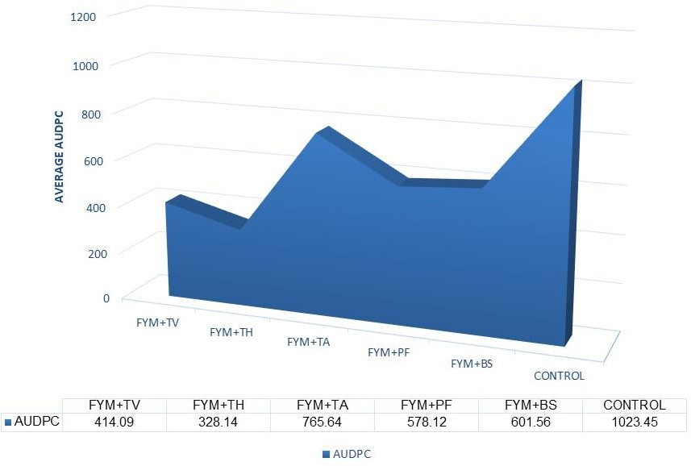
Fig.1:AUDPCstudyofdifferentbio-controlagentsoncuminwiltdisease(2022-23)

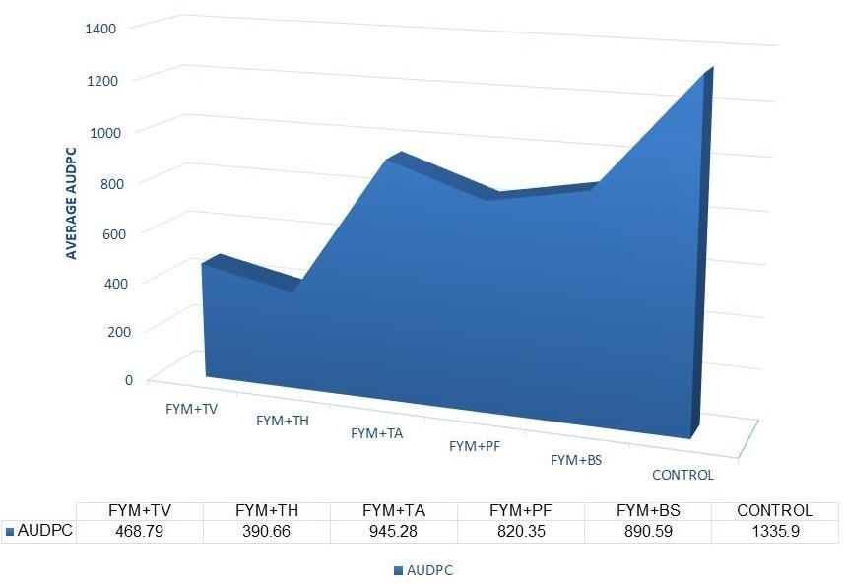
Fig.2:AUDPCstudyofdifferentbio-controlagentsoncuminwiltdisease(2023-24)

The consistent increase in seed yield with T2and T1treatmentscanbeattributedtothedualbenefitsofdisease suppressionandplantgrowthpromotion.Thebio-control agents Trichoderma harzianum and Trichoderma viride effectively suppressed cumin wilt disease by antagonizing the pathogen and enhancing soil health. Thesefungialsopromotedrootdevelopmentandnutrient uptake, which are critical for higher productivity. In contrast, the control, with no bio-control agents, had higher disease incidence and poorer plant health, resulting in reduced yields. Thus, bio-control agents not only provide effective disease management but also support sustainable, higher-yielding cumin cultivation.
In line with the findings of Singh et al. (2007), who recorded minimum wilt disease incidence of 9.20 per cent with T. harzianum treatments, our results also support T. harzianum's superiority in managing cumin wilt. The present studyobserved that T. harzianum (T2) resultedinthelowestdiseaseincidence,withvaluesof
4.17 per cent and 5.08 per cent in the first and second years, respectively, which were significantly better than thecontroltreatment,whichshowedmuchhigherdisease incidence (24.94% in 2022-23 and 33.30% in 2023-24).
Similarly, T. viride (T1) also showed effective results, with disease incidence at par with T. harzianum (T2), supporting findings from various researchers. Gangopadhyay and Gopal (2010) reported that T. viride applied with farmyard manure resulted in the greatest reduction in disease incidence under greenhouse conditions. In the present study, the soil application of farmyardmanureenrichedwithT.viride(T1)alsohowed effectivediseasecontrol,withdiseaseincidencesof5.08
per cent (2022-23) and 6.08 per cent (2023-24), both significantly lower than the control treatments.
The observed reduction in disease incidence can be attributed to the biocontrol potential of T. viride and T. harzianum, both of which exhibit strong antagonistic properties against Fusarium oxysporum. These Trichoderma species act by competing for space and nutrients,producingantifungalmetabolites,andinducing systemic resistance in plants, all of which contribute to pathogen suppression.
Regarding seed yield, both T. viride and T. harzianum treatmentsalsoproducedsignificantlyhigheryieldsthan the control. In the first year, T. harzianum (T2) gave the highestseedyieldof6.46q/ha,whichwasatparwith T. viride(T1)at6.12q/ha,whilethecontrolproducedonly
2.53 q/ha. Similar trends were observed in the second year, where T. harzianum (T2) gave a yield of6.62 q/ha andT.viride(T1)produced6.35q/ha.,bothsignificantly outperforming the control (2.25 q/ha). These results corroborate the findings of Deepak et al. (2008), who observed a significant increase in plant growth and biomass with T. harzianum treatments.
The increase in seed yield can be attributed to the enhanced plant health and reduced disease incidence, leading to better overall plant development and productivity. Additionally,the improved nutrientuptake and disease suppression likely contributed to higher yields in both T. viride and T. harzianum treatments, as observed by Kumar et al. (2016), who reported reduced disease incidence and enhanced plant growth with T. viride in cumin.

Overall, both T. viride and T. harzianum proved to be highly effective in managing cumin wilt disease and improving seed yield. T. harzianum, however, consistently demonstrated superior performance in reducing disease incidence and enhancing seed yield, making it a promising biocontrol agent for the management of cumin wilt disease.

Conclusions
The present investigation establishes that biological management through FYM enriched with effective microbial antagonists offers a practical and sustainable approach for reducing Fusarium wilt of cumin. Among theevaluatedtreatments,TrichodermaharzianumandT. viride demonstrated consistent disease-suppressive potential along with improved crop productivity. Their performance indicates that enrichment of FYM with suitable Trichoderma spp. can strengthen the biological suppression of F. oxysporum f. sp. cumini under field conditions. The findings support integrating these bioagents into eco-friendly disease management practices for cumin. Further studies on their long-term efficacy and integration with other compatible management components would help strengthen their adoption under diverse production conditions.

Acknowledgements
The authors are grateful to the Research Scientist, Seed Spices Research Station, Sardarkrushinagar Dantiwada Agricultural University, Jagudan (Dist. Mehsana) for providing the required seed material, experimental land and facilities for volatile oil estimation, which greatly supported the successful execution of this study.

Declarationofintereststatement
The authors declare that there is no conflict of interest associated with this publication.

Authorcontributions
B.K. Prajapati: Conceptualization, methodology, investigation, data curation, formal analysis, writing an original draft. N. R. Patel: Conceptualization, methodology,supervision,datacuration,writing-review and editing. Both authors have read and approved the final version of the manuscript.

References
Anonymous. (2024a). Major spice producing states in India. Retrieved from www.indianspices.com/sites/majorspicestatewise202
4.pdf
Dar,E.A.,Mehdi,M.,Ahmad, M.,Bhat,F.N., Hussain,
N.&Hussain,M.,(2019).Cumin:Theflavourof
Indian cuisines-history, cultivation and uses. Chem Sci Rev Lett, 8 (29): 129–135.
DeepakP.,Saran,L.,&Lal,G.,(2008).Controlofwiltand blight diseases of cumin through antagonistic fungi under in vitro and field conditions. Notulae Botanicae Horti Agrobotanici Cluj-Napoca, 36(2): 91–96. https://doi.org/10.15835/nbha36276
Didwania, N., (2019). Diseases of cumin and their management. In: Diseases of Medicinal and Aromatic Plants and Their Management. Today and Tomorrow Printers and Publishers, New Delhi, pp 339–345.
Gangopadhyay, S., & Gopal, (2010). Evaluation of Trichoderma spp.along withfarmyard manureforthe management of Fusarium wilt of cumin (Cuminum cyminum L.). JSpicesAromatCrops,19(1&2):57–60.
Guenther, E., (1972). The essential oils: Vol. 1. History-origininplants-production-analysis.D.VanNostrand Company Inc., New York.
Jadon, K.S., Rajput, L.S., Choudhary, Khushwant, B., Mawar, Ritu., Solanki, R.K., & Kakani, R.K. (2025). Current Status and Emerging Trends in Diseases of Cumin (Cuminum cyminum L.): Challenges and Management Strategies. Int. J Seed Spice.15(1): 1-16.
Kumar, S., Gangopadhyay, S., & Godara, S.L., (2016). Antagonistic potentiality of bioagents against wilt of cumin (Cuminum cyminum) caused by Fusarium oxysporum f. sp. cumini. Indian J Agric Sci, 86(10): 122–128.
Shaner, G., & Finney, R.E., (1977).The effect of nitrogen fertilization on the expression of slow-mildewing resistanceinknoxwheat.Phytopathology,67(8):1051–1056.
Singh, G., Maurya, S., de, Lampasona, M.P., & Catalan, C.A.N., (2006). Chemical constituents, antifungal and antioxidative potential of volatile oil and acetone extract of Cuminum cyminum L. seeds. J Sci Food Agric, 86(1): 94–100.
Singh, H.B., Srivastava, S., Singh, A., & Katiyar, R.S., (2007). Field efficacy of Trichoderma harzianum application on wilt disease of cumin caused by Fusarium oxysporum f. sp. cumini. J Biol Control, 21(2): 317–319.
Singh, S., Balamurugan, K., Kushwaha, K., Alam, S., & Kesharwani, A., (Eds.). (2025). Ecology of Soil Borne Plant Pathogens, pp. 269–293. Textify Publishers, Lucknow, India. ISBN: 978-93-48217-44-8.

