 | https://epubs.icar.org.in/index.php/IJSS  International Journal of Seed Spices(IJSS)  Vol. 16(1) June 2026 | 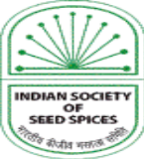

Exploiting genetic variability for the selection of disease-resistant, early-maturing, and bold-seeded fenugreek (Trigonella foenum-graecum L.) genotypes
Shyam Sunder Meena*, MK Vishal, RD Meena, YK Sharma, SS Meena, Ravi Y and MD Meena
:
Reviewed by:  Dr. Ramesh Kumar Solanki  ICAR-Central Arid Zone Research Institute, Jodhpur  Rajasthan, India  Email: rksolanki.ars@gmail.com  *Correspondence:  Shyam Sunder Meena  Email: ssmeena123@gmail.com  Received:04 August 2026  Revised:01 September2026  Accepted: 18 September 2026  Citation:  Meena, S.S., Vishal, M.K., Meena, R.D., Sharma, Y.K., Meena, S.S., Ravi, Y., & Meena, M.D., (2025) Exploiting genetic variability for the selection of disease-resistant, early-maturing, and bold-seeded fenugreek (Trigonella foenum-graecum L.) genotypes. Int J Seed Spice.16 (1): 13-19.  DOI:https://doi.org/10.56093/IJSS.v16i1.2  Affiliation:  ICAR-National Research Centre on Seed Spices, Ajmer, Rajasthan-305206 India |  | Abstract  Exploiting genetic variability is fundamental to developing superior fenugreek (Trigonella foenum-graecum L.) cultivars with enhanced yield, seed quality, and disease resistance. We evaluated 750 fenugreek accessions conserved at the ICAR–National Research Centre on Seed Spices, Ajmer, India, during the 2022–23 and 2023–24 rabi seasons to characterise phenotypic diversity and identify elite donor genotypes for trait-specific breeding. Ten agro-morphological and yield-related traits, together with field resistance to downy mildew and powdery mildew, were recorded under replicated field conditions. All traits showed significant phenotypic variation. Plant height, seeds per pod, test weight, and seed yield per plant exhibited the greatest variability, whereas days to flowering and maturity showed comparatively narrower variation. Disease reactions ranged from highly resistant to highly susceptible, indicating substantial genetic diversity for resistance; however, most highly resistant accessions displayed relatively lower yield potential, highlighting the challenge of combining disease resistance with productivity. After single-plant selection and progeny evaluation, we identified three elite donor genotypes. AM-478-22 combined high resistance to powdery mildew (PDI 9.5%) with moderate resistance to downy mildew (PDI 26.1%) and produced approximately 14% higher seed yield than the standard checks. AM-281-2 matured in 125 days, approximately 15 days earlier than the check cultivars, while AM-378-5 consistently expressed bold seeds with a test weight exceeding 20 g and stable yield across seasons. These genotypes constitute valuable genetic resources for fenugreek improvement and provide promising donor parents for pyramiding high yield, earliness, bold seed size, and disease resistance in future breeding programmes.  Keywords: disease-resistant, early-maturing, bold-seeded fenugreek, Trigonella foenum-graecum L.,

Introduction
Fenugreek (Trigonella foenum-graecum L.), commonly known as methi, is an important self-pollinated annual legume cultivated worldwide as a spice, condiment, leafy vegetable, fodder, feed, and medicinal crop with diverse industrial applications (Ahamad et al., 2016). Beyond its culinary value, fenugreek has attracted considerable attention due to its broad spectrum of pharmacological properties, including anti-diabetic, anti-inflammatory, antioxidant, hypocholesterolemic, and antimicrobial activities. In addition, fenugreek gum is widely used in the food industry as a stabilizer, emulsifier, thickening agent, and adhesive. It is incorporated into a variety of bakery, confectionery, and extruded food products owing to its excellent functional properties (Wani and Kumar, 2018). The crop is native to the West Asian and Mediterranean regions and is now cultivated extensively across several countries. In India, fenugreek is predominantly grown in Rajasthan, Gujarat, Madhya Pradesh, and Uttar Pradesh, which together form the crop's major production belt.

Organized research on fenugreek in India received significant impetus with the establishment of the All India Coordinated Research Programme on Spices (AICRPS) and the ICAR–National Research Centre on Seed Spices (ICAR–NRCSS), Ajmer, in 2000. Since then, these initiatives have substantially strengthened genetic improvement programmes, resulting in the development and release of more than 100 improved seed spice varieties, including over 20 fenugreek varieties developed by ICAR institutes and State Agricultural Universities (SAUs). ICAR–NRCSS has also been designated as the National Active Germplasm Site (NAGS) for seed spices, with a mandate to collect, characterise, evaluate, conserve, maintain, and distribute germplasm resources. Currently, the institute conserves more than 750 fenugreek accessions representing diverse geographical origins and agro-climatic regions, providing an invaluable genetic resource for crop improvement.

Genetic diversity is the cornerstone of crop improvement, providing the variability needed to identify and select superior genotypes with desirable agronomic, quality, and stress-resilience traits (Govindaraj et. al., 2015; Demelashet. al., 2023). Comprehensive characterization and evaluation of germplasm collections are therefore indispensable for effective utilization in breeding programmes and for broadening the genetic base of cultivated varieties (Salgotra et al, 2024). In this context, the present investigation assessed the extent of phenotypic variability and estimated key genetic parameters governing economically important traits in a diverse fenugreek germplasm collection. Furthermore, we identified trait-specific superior genotypes through single-plant selection to develop genetically pure lines with desirable attributes, including early maturity, bold seed size, disease resistance, and high seed yield. The identified elite genotypes constitute valuable genetic resources for varietal development, donor parents in hybridization programmes, studies on the inheritance of economically important traits, and the development of molecular markers and marker-assisted breeding strategies to accelerate genetic improvement in fenugreek. These selected genotypes will serve as potential varieties, donor lines for genetic improvement, valuable genetic resources for studying the inheritance of important traits, and parental material for developing molecular markers and marker-assisted breeding programmes.

Materials and Methods

Germplasm Collection, Conservation, and Experimental Evaluation
Germplasm collection, characterization, evaluation, and conservation form the cornerstone of genetic improvement programmes in fenugreek (Trigonella foenum-graecum L.). Since its establishment, the ICAR-National Research Centre on Seed Spices (ICAR-NRCSS), Ajmer has assembled acomprehensive collection of more than 750 fenugreek germplasm accessions through systematic acquisitions from State Agricultural Universities located in Rajasthan, Gujarat, Andhra Pradesh, Haryana, Uttar Pradesh, Madhya Pradesh, Karnataka, Bihar, and Himachal Pradesh, in addition to accessions procured from ICAR–National Bureau of Plant Genetic Resources (ICAR-NBPGR), New Delhi, and extensive field explorations across major fenugreek-growing regions of India. ICAR-NRCSS has been designated as the National Active Germplasm Site (NAGS) for the conservation, maintenance, characterization, and distribution of germplasm of ten economically important seed spice crops, including fenugreek. A total of 750 fenugreek accessions were evaluated over two consecutive rabi seasons, comprising 300 accessions during 2022–23 and 450 accessions during 2023- 24. Five nationally released varieties, namely AFG-3, AFG-4, AFG-5, Hisar Sonali, and RMt-361, were included as standard checks. The experiment used an augmented block design, in which all germplasm accessions and check varieties were planted in paired rows 4.0 m long. Inter-row and intra-row spacing of 30 cm and approximately 10 cm, respectively, were maintained through manual thinning after establishment. The team uniformly adopted recommended agronomic and crop protection practices throughout the experimental period to ensure optimal crop growth and minimize environmental variation.

Trait Recording and Disease Assessment
Phenotypic observations were recorded for ten economically important traits, namely days to 50% flowering, days to maturity, plant height (cm), number of primary branches per plant, number of pods per plant, pod length (cm), number of seeds per pod, 1000-seed weight (g), seed yield per plant (g), and the incidence of downy mildew and powdery mildew. For quantitative morphological traits, observations were recorded from five randomly selected competitive plants within each accession, and the mean values were used for subsequent analyses. Disease reactions against downy mildew and powdery mildew were assessed under natural field conditions using the 0-4 disease rating scale described by Prakash and Saharan (1999), wherein disease reactions were classified as immune (0), resistant (1-15%), moderately resistant (16-30%), susceptible (31-50%), and highly susceptible (>50%). Disease ratings were converted into Percentage Disease Index (PDI) for quantitative assessment of disease severity.

Selection of Superior Germplasm
The extent of phenotypic variability for seed yield and associated agronomic traits was assessed using the observed range and mean values across the two years of evaluation. Based on predefined selection criteria for key yield-contributing and disease-resistance traits (Table 1), we practised trait-specific single-plant selection within promising germplasm accessions. Superior plants were isolated following the pure-line selection method and subsequently advanced through successive stages of plant-to-row progeny evaluation, preliminary evaluation trials, and replicated yield trials conducted during 2023–2026 to identify genetically stable and agronomically superior lines suitable for varietal development and crop improvement. Germplasm collection, evaluation, and conservation constitute the foundation of any crop improvement programme. Since its establishment, ICAR-NRCSS, Ajmer has assembled more than 750 fenugreek germplasm accessions collected from agricultural universities located in Rajasthan, Gujarat, Andhra Pradesh, Haryana, Uttar Pradesh, Madhya Pradesh, Karnataka, Bihar, and Himachal Pradesh, as well as from ICAR-NBPGR, New Delhi, and through extensive field explorations. The institute has been designated as the National Active Germplasm Site (NAGS) for conserving, maintaining, and distributing germplasm of ten seed spice crops, including fenugreek. The entire fenugreek germplasm collection was evaluated during two consecutive rabi seasons, 2022-23 (300 accessions) and 2023-24 (450 accessions), along with five released check varieties, namely AFG-3, AFG-4, AFG-5, Hisar Sonali, and RMt-361. The experiment followed an augmented block design in which all test entries and check varieties were sown in paired rows 4 m long (ANOVA not given). A row spacing of 30 cm and plant spacing of about 10 cm were maintained through manual thinning. All recommended agronomic and plant protection practices were followed to raise a healthy crop.
Observations were recorded on ten important traits, namely days to flowering, days to maturity, plant height, number of primary branches per plant, number of pods per plant, pod length, number of seeds per pod, 1000-seed weight (test weight), seed yield per plant, and the incidence of downy mildew and powdery mildew. For morphological observations, we recorded data from five randomly selected plants in each accession and used the mean values for analysis. Disease severity of downy mildew and powdery mildew was assessed and converted into the Percentage Disease Index (PDI). The range and mean values of seed yield and other important yield-attributing traits were determined based on observations recorded during the two years of evaluation. Trait-specific single-plant selection was subsequently practised within promising germplasm accessions using predefined selection criteria for important yield-attributing traits (Table 1). Pure-line selection was followed to isolate superior plants for different target traits. Selected plants were advanced through plant-to-row progeny evaluation, initial evaluation trials, and replicated yield trials during 2023-2026.

Results and Discussion
Variability in the fenugreek germplasm assemblage
Evaluation of the complete fenugreek germplasm assemblage comprising 750 accessions during the rabi seasons of 2022–23 and 2023–24 revealed substantial phenotypic variability for eight quantitative traits and resistance to downy mildew and powdery mildew. Considerable variation was observed across all measured traits, indicating a broad genetic base for selection and crop improvement.
The widest range of variation was recorded for plant height (35.8–106.4 cm), followed by 1000-seed weight (4.7–22.8 g), seed yield per plant (3.0–21.0 g), and number of seeds per pod (9.0–22.5), with corresponding mean values of 71.1 cm, 12.6 g, 7.4 g, and 18.0, respectively. In contrast, relatively narrow variation was observed for days to maturity (126–148 days), days to 50% flowering (50–79 days), and number of primary branches per plant (2.6–10.3), with mean values of 136 days, 58.8 days, and 4.2 branches, respectively. The coefficient of variation (CV) for the quantitative traits ranged from 4.7% to 45.8%. The lowest CV was recorded for days to 50% flowering (4.7%), followed by pod length (13.5%) and days to maturity (14.5%), indicating relatively limited phenotypic variability for these traits. In contrast, the highest CV was observed for number of primary branches per plant (45.8%), followed by 1000-seed weight (34.2%), whereas the remaining traits exhibited moderate variability (25–35%) (Table 1).

The wide phenotypic variation observed for seed yield and its associated traits highlights the substantial scope for identifying superior recombinants and developing improved cultivars through selection. Meena et al. (2022, 2025), Al-Maamari et al. (2020), Choudhary et al. (2017), and Berhe et al. (2025) have also reported comparable levels of genetic variability in fenugreek, confirming rich genetic diversity within global fenugreek germplasm collections. Disease severity, expressed as Percentage Disease Index (PDI), also varied considerably among accessions, ranging from 7.0 to 87.0%, with CV values of 38.9% for downy mildew and 49.8% for powdery mildew. Although several accessions showed high resistance to both diseases, many of these resistant genotypes had comparatively lower yield potential. This observation suggests that disease resistance and productivity are not always positively associated and emphasizes the need to improve both traits simultaneously through targeted breeding and selection. Selection of trait-specific superior genotypes

Table 1: Evaluation of fenugreek germplasm for seed yield and attribute traits
S. N. | Characteristics | Range | Mean | CV  (%) | Mean of  Checks | Landmark for selection
1. | Days to 50 % flowering | 50.0-79.0 | 58.8 | 4.7 | 55.8 | >50
2. | Days to 75 % maturity | 126-148 | 136 | 14.5 | 138 | >120
3. | Plant height (cm) | 35.8-106 | 71.1 | 28.7 | 74.6 | 60-75
4. | No. of primary branches/plant | 2.6-10.3 | 4.2 | 45.8 | 5.4 | 5-8
5. | Pod length (cm) | 7.5-11.5 | 9.2 | 13.5 | 8.8 | 8-10
6. | No. of seed/pod | 9.0-22.5 | 18.0 | 26.4 | 17.0 | 16-18
7. | 1000-seed Weight (g) | 4.7-22.8 | 12.6 | 34.2 | 13.8 | 16-20
8. | Seed yield (g/plant) | 3.0-21.1 | 7.4 | 42.8 | 8.5 | -
9. | Downy mildew (PDI) | 10.0-86 | 40.4 | 38.9 | 55.7 | <15
10. | Powdery mildew (PDI) | 7.0-87.0 | 45.6 | 49.8 | 64.8 | <15

As part of the genetic enhancement programme at ICAR–National Research Centre on Seed Spices (ICAR-NRCSS), Ajmer, the entire germplasm collection was systematically evaluated to identify superior genotypes for economically important agronomic, yield, and disease-resistance traits. Single-plant selection was practised within promising accessions to isolate elite lines possessing desirable combinations of early maturity, higher pod-bearing capacity, bold seed, moderate plant stature, resistance to major diseases, and superior seed yield relative to the released check varieties. The primary objective of the selection programme was to develop climate-resilient fenugreek cultivars suitable for emerging production environments characterized by shortened cropping windows, limited irrigation resources, terminal heat stress, and reduced dependence on chemical plant protection measures. Based on initial screening, we advanced ten promising selections with desirable combinations of disease resistance, early maturity, bold seed, and high yield to replicated station trials and evaluated them for two consecutive years (2024–25 and 2025–26). Mean performance over two years helped identify superior trait-specific selections, the details of which are presented below, while the corresponding data are summarised in Table 2.

AM-478-22: A powdery mildew-resistant selection
Extensive screening of the germplasm collection identified several accessions exhibiting resistance to powdery mildew and moderate resistance to downy mildew. However, most of these resistant accessions had relatively poor seed yield. To overcome this limitation, single-plant selection was practised within resistant accessions exhibiting a PDI below 15% to improve productivity while retaining disease resistance. Four promising accessions (AM-271, AM-308, AM-335, and AM-478) were selected for recurrent selection and progeny evaluation (Anonymous, 2023, 2024, 2025).Among the evaluated progenies, AM-478-22 consistently demonstrated an excellent combination of disease resistance and improved productivity. Based on pooled performance over two years of replicated trials (2024–25 and 2025–26), the genotype recorded a powdery mildew PDI of only 9.5%, indicating high resistance, while downy mildew severity remained moderate (26.1% PDI). Furthermore, the genotype produced approximately 14% higher seed yield than the released check varieties (Table 2). The selected line matured within a duration comparable to the checks and maintained similar 1000-seed weight and seeds per pod, while exhibiting slightly shorter plant stature.

The successful recovery of a high-yielding, disease-resistant genotype demonstrates the effectiveness of within-accession selection for improving complex traits. Meena et al. (2025) reported similar enhancement of powdery mildew resistance through mutation breeding. Owing to its stable disease resistance, satisfactory agronomic performance, and superior yield, AM-478-22 represents a valuable candidate for varietal development and can also serve as an important donor parent in resistance breeding programmes. The genotype may further be considered for registration as a valuable genetic stock.

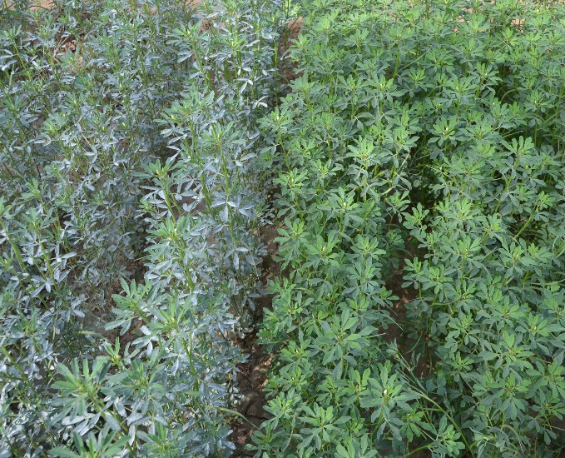 | 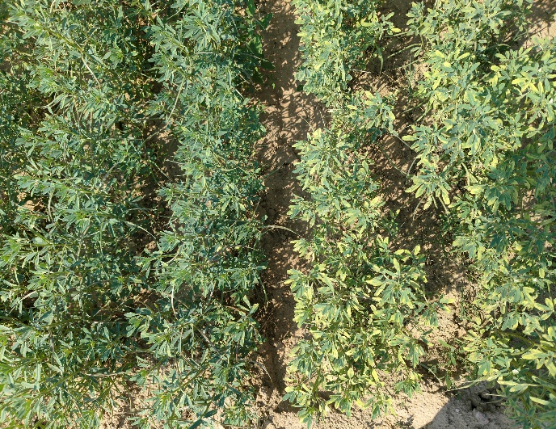
Fig. 1: Left- Susceptible check; Right- Resistant selection (AM-478-22) to Powdery mildew disease. | Fig. 2: Left- Susceptible check; Right- Resistant selection (AM-478-22) to Downy mildew disease.
Table 2: Performance of promising selections based on two years' pooled data

S  N | Genotype | Test  weight  (g) | Days  to  maturity | Plant  hight  (cm) | No. of  seed/  pod | Downy  Mildew disease |  | Powdery  Mildew disease |  | Seed  yield  (kg/ha) | % yield increase over check
 |  |  |  |  |  | PDI | DR | PDI | DR
1 | AM-45 | 15.8 | 138 | 78.7 | 18.0 | 59.6 | HS | 56.3 | HS | 2523 | 5.4
2 | AM-50 | 13.9 | 140 | 77.5 | 17.6 | 55.5 | HS | 44.6 | S | 2523 | 5.4
3 | AM-319-32 | 14.1 | 141 | 81.5 | 17.4 | 34.9 | S | 10.8 | R | 2721 | 12.3
4 | AM-478-22 | 15.6 | 141 | 78.7 | 17.2 | 26.1 | MR | 9.5 | R | 2775 | 14.0
5 | AM-506 | 14.8 | 140 | 76.5 | 17.8 | 59.6 | HS | 27.8 | MR | 2598 | 8.1
6 | AM-541 | 15.8 | 140 | 80.0 | 18.4 | 47.8 | S | 50.6 | S | 2577 | 7.4
7 | AM-644 | 15.5 | 140 | 85.2 | 17.8 | 62.8 | HS | 12.1 | R | 2681 | 11.0
8 | AM-278-11 | 15.2 | 142 | 88.3 | 16.3 | 46.3 | S | 45.4 | S | 2494 | 4.3
9 | AM-281-2 | 18.8 | 125 | 71.1 | 15.9 | 65.3 | HS | 33.6 | S | 2259 | -5.7
10 | AM-378-5 | 20.6 | 139 | 84.4 | 15.7 | 48.4 | S | 41.2 | S | 2307 | -3.5
11 | AFg-3 | 14.6 | 142 | 91.7 | 17.5 | 75.3 | HS | 54.5 | HS | 2346 | -1.8
12 | Hisar Sonali | 14.8 | 141 | 94.0 | 16.7 | 59.5 | HS | 60.1 | HS | 2355 | -1.5
13 | RMt-361 | 15.0 | 141 | 85.2 | 17.0 | 54.0 | HS | 74.0 | HS | 2371 | -0.7
14 | Mean | 15.7 | 139.0 | 82.5 | 17.2 | 53.1 | – | 39.9 | – | 2502 | –
15 | SEm (±) | 1.3 | 1.5 | - | - | 6.57 | – | 4.87 | – | 47.6 | –
16 | CD (5%) | 2.5 | 5.1 | - | NS | 18.85 | – | 14.35 | – | 141 | –

PDI- Percent disease index (%); DR- Disease reaction = R- Resistant, MR- Moderatly resistant, S- Susceptible, HS- Highly susceptible

AM-281-2: An early-maturing selection
Among the early-maturing selections, AM-281-2 emerged as the most promising genotype, attaining physiological maturity within 125 days, approximately 15–20 days earlier than the released check varieties, which required 140–145 days. Early maturity is a highly desirable trait in fenugreek breeding because it enables the crop to escape terminal heat and moisture stress and facilitates its integration into intensive cropping systems. In addition to earliness, AM-281-2 possessed bold seeds with a 1000-seed weight of 18.8 g compared with approximately 15 g in the check varieties. The genotype exhibited a comparatively shorter plant stature, being nearly 15 cm shorter than the checks, while maintaining a similar number of seeds per pod. Although its seed yield was about 5% lower than that of the released varieties, its substantially earlier maturity is expected to compensate for this yield reduction under late-sown, water-limited, and terminal heat stress conditions.
Currently, no commercially released fenugreek variety in India matures in less than 130 days. Therefore, AM-281-2 represents a valuable genetic resource for breeding extra-early cultivars adapted to changing climatic conditions and intensive cropping sequences. Singh et al. (2021) previously reported similar early-maturing germplasm.

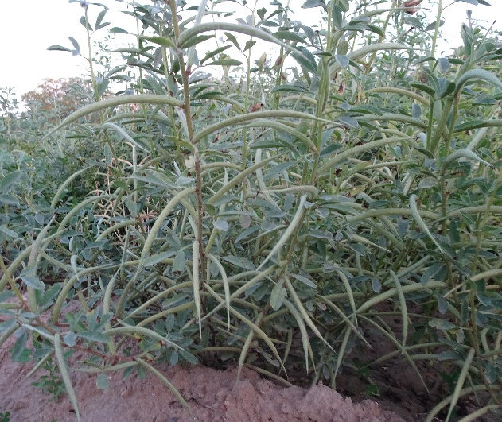 | 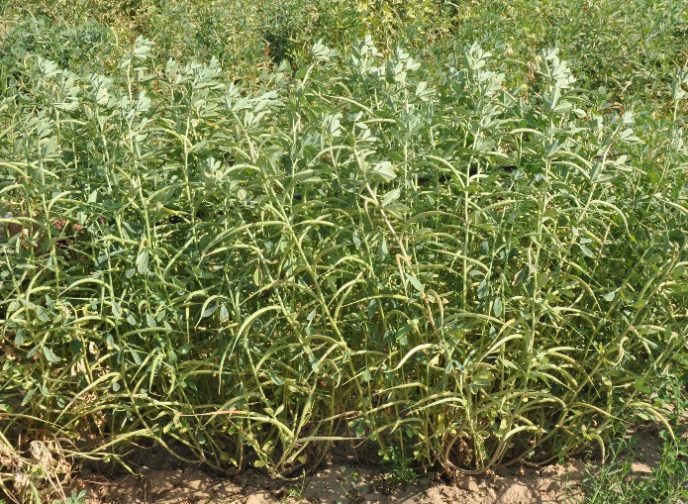
Fig. 3: AM-281-2: Early maturing selection. | Fig. 4: AM-378-5: Bold-seeded selection.

AM-378-5: A bold-seeded selection

Considerable variabBold-seed fertility was observed among the evaluated germplasm, with 1000-seed weight ranging from 4.7 to 22.8 g. Although several accessions possessed bold seeds, most exhibited comparatively poor seed yield. In this investigation, genotypes with a 1000-seed weight exceeding 18 g were classified as bold-seeded, whereas the released check varieties generally recorded about 15 g. Among these, AM-378-5 consistently exceeded 20 g 1000-seed weight across environments while maintaining seed yield statistically comparable to the check varieties. Although the genotype produced slightly fewer seeds per pod, the reduction was effectively compensated by its substantially higher individual seed weight, resulting in comparable overall productivity.

Preliminary quality analysis also indicated that AM-378-5 had significantly higher gum content than the existing cultivars, enhancing its potential value for food processing and industrial applications. Seed size is an important quality attribute because larger seeds generally contain greater nutrient reserves, exhibit superior germination and seedling vigour, and contribute to improved crop establishment and commercial value (Ebadi and Hisoriev, 2011; Cao et al., 2011). Consequently, AM-378-5 represents a valuable genetic resource for breeding programmes aimed at improving seed quality, processing characteristics, and industrial end-use traits while maintaining competitive yield performance.

Acknowledgements

The authors gratefully acknowledge the financial support and research facilities provided by the Department of Agricultural Research and Education (DARE), Government of India, and the Indian Council of Agricultural Research (ICAR). The authors also express their sincere gratitude to the Director, ICAR–National Research Centre on Seed Spices, Ajmer, for providing the necessary facilities and continuous encouragement during this investigation.

Conflict of Interest

The authors declare no conflicts of interest that could have influenced the research or its reporting of the research presented in this manuscript.

Reference

Acharya, S., Anchalee,& Saikat, B., (2006). Improvement in the nutraceutical properties of fenugreek (Trigonella foenumgraecum L.) Songklanakarin J. Sci. Tech. 28(1): 1-9.
Ahamad, A., Alghamdi, S. S., Mahmood, K., & Afzal, M., (2016). Fenugreek a multipurpose crop: potentialities and improvements. Saudi J. Biol. Sci. 23, 300–310 (2016).
Al-Maamari, I., T., Khan, M. M., Al-Sadi, A. M., Iqbal, Q. & Al-Saady, N., (2020). Morphological characterization and genetic diversity of Fenugreek (Trigonella foenum-graecum L.) accessions in Oman. Bulgarian J. of Agric. Sci., 26 (2): 375–383
Anonymous (2023). Annual Report, ICAR-National Research Centre on Seed Spices, Ajmer. 2023 p 11-12.
Anonymous (2024), Annual Report, ICAR-National Research Centre on Seed Spices, Ajmer. 2024 p 20-21.
Anonymous (2025), Annual Report, ICAR-National Research Centre on Seed Spices, Ajmer, 2025, pp. 15- 16.
Berhe, Z., Awas, T., Dejen, A., Adane, M., Akele, B., Adal, M., & Hailu, F., (2025). Unlocking the genetic potential of Ethiopian fenugreek (Trigonella foenum-graecum L.) genotypes for future breeding. J.Heliyon e 42321 DOI: https://doi.org/10.1016/e42321
Cao, H.W., Zhang, H., Chen, Z.B., Wu, Z.J., & Cui, Y.D., (2011). Chinese traditional medicine matrine: A review of its antitumor activities. J. Med. Plants Res., 5(10): 1806-1811
Choudhary, M., Gothwal, D.K., Kumawat, R. & Kumawat, K.R., (2017). Assessment of Genetic Variability and Character Association in Fenugreek (Trigonella foenum-graecum L.) Genotypes. Int. J. Pure App. Biosci. 5(5): 1485-1492. DOI: https://dx.doi.org/10.18782/2320-7051.5110
Demelash, A. Book chapter: Resistance Sources for Powdery Mildew and Breeding Strategies for Improvement in Fenugreek. Advances in Agriculture, (2023).
Ebadi, A.G., &Hisoriev, H., (2011). Review on Distribution of Sambucus ebulus L. In the North of Iran. Am. Euras. J. Agric. Environ. Sci., 10(3): 351-353.
Govindaraj, M., Vetriventhan, M., & Srinivasan, M., (2015). Importance of Genetic Diversity Assessment in Crop Plants and Its Recent Advances: An Overview of Its Analytical Perspectives. Genet Res Int. 2015 1–14. DOI: https://doi.org/10.18805/LR-4090
Meena, R.S., Choudhary, S., Verma, A.K., Meena, N.K.,
& Mali, S.C., (2021). Estimates of genetic variability, divergence, correlation and path coefficient for morphological traits in Fenugreek (Trigonella foenum-graecum L.) genotypes. Legume Res. 44:281-286.
Singh, O.V., Kartar S., Meena, V.S., Shekhawat, N., & Gupta, V., (2021). Identification of an extra early maturing accession IC 0624520 of fenugreek (Trigonella foenum-graecum L.). Int. J. Seed Spices 11(2): 50-52.
Prakash, S., & Saharan, G., (1999). Sources of resistance
to downy and powdery mildew of fenugreek. Indian J.of Mycology and Plant Pathology. 36: 95-99.
Meena, R.S., Meena, N.K., Saxena, S.N., Verma, A.K., Ravi Y. and Bagra, S.K. 2022. Estimation of genetic variability, correlation and divergence studies on seed yield and its attributing characteristics in fenugreek(Trigonella foenum-graecum L.). Int. J. Seed Spice, 12 (2): 63-69. DOI: https://doi.org/10.56093/IJSS.v92i1.8
Salgotra, R.K., & Chauhan, B.S., (2023). Genetic Diversity, Conservation, and utilization of plant genetic resources. Genes (Basel). 14, 174 (2023).
Meena, S.S., Meena, R.D., Meena, R.S., Sharma, Y.K., Kumar, Sanjay, Meena, N.K., Meena, S.S., & Y., Ravi., (2025). Gamma irradiation induced powdery mildew disease resistance in fenugreek (Trigonella foenum -graecum L.). Int. j. Seed Spices. 15(1): 65-72. DOI:

https://doi.org/10.56093/IJSS.v15i1.5
Meena, V.S., Meena, V.K., Bhardwaj, R., Singh, K., Shekhawat, N. & Shukla, A.K., (2025). Genetic diversity and agro-morphological characterization of Fenugreek (Trigonella foenum-graecum L.) germplasm provides insight for breeding and crop improvement. Scientific Reports, 16, 2324. DOI: https://doi.org/10.1038/s41598-025-32066-y
Wani, S.A. & Kumar, P., (2018). Fenugreek A review on its nutraceutical properties and utilization in various food products. J. Saudi Soc. Agric. Sci. 17, 97–106.

