 | https://epubs.icar.org.in/index.php/IJSS  International Journal of Seed Spices(IJSS)  Vol. 16 (1) June 2026 | 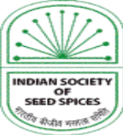

Sustainable control of Fusarium oxysporum in cumin (Cuminum cyminum L.) through intervention of botanicals, antagonistic fungi, and soil solarization
Ram Dayal Meena¹*, Yugal Kishor Sharma¹, Narayan Lal Meena², Narottam Kumar Meena¹, Shyam Sundar Meena¹, Narendra Chaudhary¹, Murli Dhar Meena¹, Sumer Singh Meena¹, Kartar Singh¹ and Vinay Bhardwaj¹
Reviewed by:  Dr. P.P. Thirumalaisamy  Email: thirumalaisamypp@yahoo.co.in  *Correspondence:  Ram Dayal Meena  Email: meenard2005@gmail.com  Received: 14August 2026  Revised: 15 September 2026  Accepted:28 September 2026  Citation:  Meena R.D., Sharma Y. K., Meena, N.L., Meena, N.K., Meena, S.S., Chaudhary, N., Meena, M. D.,Meena, S. S.,Singh, K., & Bhardwaj, V., (2026). Sustainable control of Fusarium oxysporum in cumin (Cuminum cyminum L.) through intervention of botanicals, antagonistic fungi, and soil solarization, Int J Seed Spice.16 (1): 32-38.  DOI: https://doi.org/10.56093/IJSS.v16i1.4  Affiliation:  ¹ICAR–National Research Centre on Seed Spices, Tabiji, Ajmer, Rajasthan 305206, India  ²Maharana Pratap University of Agriculture and Technology, Udaipur Rajasthan |  | Abstract  Fusarium wilt, caused by (Fusarium oxysporum f. sp. Cumini), is one of the most devastating diseases constraining cumin (Cuminum cyminum L.) production worldwide. A field experiment evaluated the efficacy of an integrated disease management (IDM) strategy comprising soil solarization, neem cake, and Trichoderma viride to suppress Fusarium wilt and improve crop productivity. Pooled analysis showed that all integrated treatments significantly reduced disease incidence and soil pathogen populations while increasing seed yield compared with the untreated control. Among the treatments, 20 days of soil solarization combined with neem cake (0.5 t ha⁻¹) and seed treatment with T. viride (8 g kg⁻¹ seed) proved to be the most effective, recording the lowest Percent Disease Index (PDI; 5.31), the highest disease reduction (89.7%), the greatest decline in pathogen population (81.7%), and the maximum seed yield (173 g plot⁻¹). This treatment was closely followed by 30 days of soil solarization combined with neem cake and T. viride, which achieved a PDI of 5.69, 88.7% disease reduction, and a 78.9% reduction in pathogen population. In contrast, the untreated control exhibited the highest disease severity (PDI 58.81) and the lowest seed yield (60 g plot⁻¹). Soil solarization raised soil temperature to 56.86°C at 15 cm depth, creating unfavourable conditions for pathogen survival and enhancing the efficacy of neem cake and T. viride. The synergistic integration of physical, organic, and biological approaches effectively reduced soil inoculum, suppressed Fusarium wilt, and substantially improved cumin productivity. These findings demonstrate that integrating soil solarization with neem cake and T. viride provides an environmentally sustainable and highly effective approach.  Key Words: Disease, Cumin, Botanicals, Wilt,Fusarium

Introduction
Cumin, commonly known as Jeera (Cuminum cyminum),belongs to the Apiaceae family. India is the world's leading producer, consumer, and exporter of cumin (Cuminum cyminum L.), with the crop playing a pivotal role in the country's seed spice economy. India leads cumin production (Meena et al., 2022). During the recent production season, cumin was cultivated over approximately 15.6 lakh hectares, producing around 11.63 lakh tons of seed (Anonymous, 2025), reflecting its significant contribution to Indian agriculture and the spice export sector. The crop is predominantly grown in the arid and semi-arid regions of Rajasthan and Gujarat, which together account for more than 99% of national cumin acreage and production because of their favourableagro-climatic conditions. The increasing area under cultivation and sustained production underscore the growing economic importance of cumin, driven by strong domestic demand and expanding international markets.However, productivity remains low due to several diseases, among which Fusarium wilt is one of the most damaging.

In view of the great economic importance of cumin, a coherent and comprehensive programme must be meticulously undertaken on the study of wilt and blight diseases of cumin with a view to control these diseases. Soil solarization or “solar heating” is a non-chemical disinfestation practice that may serve as a component of a sustainable IPM programme. Solarization effectively controls a wide range of soil-borne pathogens, insects and weeds. Soil solarization exploits solar energy to heat wet soil mulched with transparent PE sheets to 40–55ºC in the upper soil layer. Thermal killing is the main factor in pest control, but chemical and biological mechanisms also contribute.

Material and Methods
Experimental Site
A field experiment was conducted at the research farm of ICAR–National Research Centre on Seed Spices (ICAR–NRCSS), Tabiji, Ajmer, Rajasthan, India, during the rabi seasons from 2014–15 to 2018–19. The experimental farm is situated between 26°22′12″–26°22′31″ N latitude and 74°35′39″–74°36′01″ E longitude at an altitude of 460.17 m above mean sea level. The experimental site falls under Agro-climatic Zone III of Rajasthan.The experimental field soil was sandy loam, characterised by low fertility and poor water-holding capacity, with a pH of 8.0- 8.3, electrical conductivity (EC) of 0.07–0.12 dS m⁻¹, and 0.15–0.23% organic carbon. The available nutrient status of the soil was 178.5 kg N ha⁻¹ (low), 12 kg P₂O₅ ha⁻¹ (medium), 85 kg K₂O ha⁻¹ (low), 214.7 kg Ca ha⁻¹ (high), 258 kg Mg ha⁻¹ (medium), and 27 kg S ha⁻¹ (high).

Experimental Design and Treatments
The experiment used a Randomised Block Design (RBD) with 11 treatments and three replications. Each experimental plot measured 3 × 3 m (9 m²). The treatments were designed to evaluate the individual and combined effects of soil solarization, Trichoderma viride, neem cake, and a standard fungicidal seed treatment in managing Fusarium wilt in cumin.

Table 1. Details of Different Treatments Evaluated for the Management of cumin wilt.
Treatment | Soil Solarization Period (days) | Seed treatment | Soil application | Treatment Combination
T₁ | 10 days | — | — | Solarization for 10 days
T₂ | 20 days | — | — | Solarization for 20 days
T₃ | 30 days | — | — | Solarization for 30 days
T₄ | 10 days | Trichoderma viride @ 8 g kg⁻¹ seed | — | Solarization (10 days) + T. viride
T₅ | 20 days | Trichoderma viride @ 8 g kg⁻¹ seed | — | Sol arization (20 days) + T. viride
T₆ | 30 days | Trichoderma viride @ 8 g kg⁻¹ seed | — | Solarization (30 days) + T. viride
T₇ | 10 days | Trichoderma viride @ 8 g kg⁻¹ seed | 0.5 (t ha⁻¹) Neem Cake | Solarization (10 days) + T. viride + neem cake
T₈ | 20 days | Trichoderma viride @ 8 g kg⁻¹ seed | 0.5 (t ha⁻¹) Neem Cake | Solarization (20 days) + T. viride + neem cake
T₉ | 30 days | Trichoderma viride @ 8 g kg⁻¹ seed | 0.5 (t ha⁻¹) Neem Cake | Solarization (30 days) + T. viride + neem cake
T₁₀ | — | — | — | Untreated control
T₁₁ | — | Carbendazim @ 2 g kg⁻¹ seed | — | Chemical check

This experimental layout enabled a comprehensive evaluation of individual and integrated disease management strategies to suppress Fusarium oxysporum f. sp. cumini and improve cumin productivity under field conditions.

Soil Solarization and observations
Soil solarization was carried out following the technique described by Katan (1980). The experimental plots were irrigated to field capacity before treatment and immediately covered with 100-µm transparent polyethene sheets (Fig 1) during the hottest period before sowing. The polyethene sheets were tightly secured along the edges to minimise heat loss. Solarization was maintained for 10, 20, or 30 days, depending on the treatment, after which the sheets were removed and subsequent treatments were applied before sowing. Soil temperature was recorded at a depth of 15 cm at regular intervals throughout the solarization period using a soil thermometer.

Application of Bioagent and Neem Cake
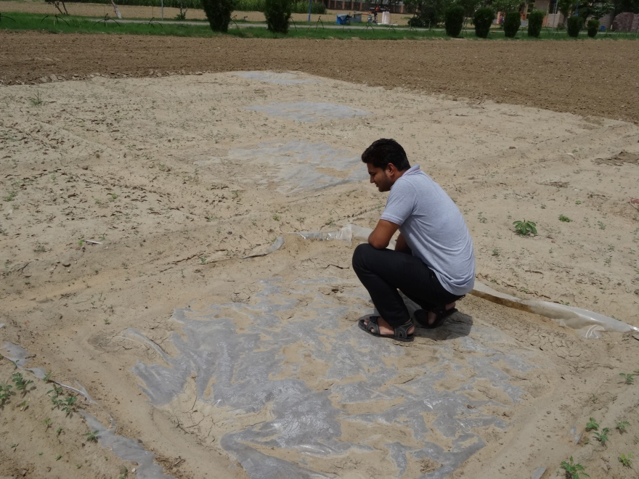
Trichoderma viride was applied as a soil treatment according to the respective treatment combinations. Neem cake was incorporated into the soil before sowing in treatments receiving the integrated application of solarization, T. viride (@8g/kg seed), and neem cake (@0.5T/ha). All other recommended agronomic practices for cumin cultivation were uniformly followed throughout the experimental period.

Disease Assessment
Fusarium wilt incidence was recorded periodically during the crop season. In each plot, we counted the total plant population and recorded healthy and wilt-infected plants separately. Disease incidence was calculated using the following formula: The per cent wilt incidence methodology is also supported by other researchers and is calculated as follows (Talaviya et al. 2017), as given for cumin wilt.

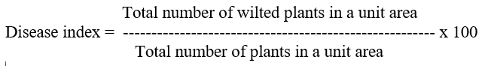

The Per cent Disease Index (PDI) was computed for each treatment based on disease incidence to evaluate the effectiveness of soil solarization and integrated disease management practices.

Statistical Analysis
The experimental data were analysed using analysis of variance (ANOVA) appropriate for a Randomised Block Design (RBD), following the procedure described by Panse and Sukhatme (1985). Treatment means were compared at the 5% level of significance (P = 0.05) wherever the F-test indicated significant differences.

Fig. 1. Practical demonstration of soil solarization: installation of polythene sheets and measurement of soil temperature at 15 cm depth using a soil thermometer

Results and discussion
The pooled data (Table 1) showed that the integrated application of soil solarization, neem cake, and Trichoderma viride significantly reduced Fusarium wilt incidence and increased seed yield in cumin. Among all the treatments, 20 days of soil solarization combined with neem cake and T. viride proved to be the most effective, recording the lowest Percent Disease Index (PDI) of 5.31, followed by 30 days of soil solarization combined with neem cake and T. viride with a PDI of 5.69. In contrast, the untreated control exhibited the highest disease incidence (PDI 58.81), indicating the severe impact of Fusarium oxysporum f. sp. cumini under non-managed conditions.

Table 2. Three years pooled data of cumin wilt on soil solarized plots explaining benefit-cost ratio (BCR)

S.  No. | Expenditure head/year /ha | Conventional  Method (Rs/year/ha) | Soil Solarization (Rs/year/ha)
1 | Soil preparation | = 10000 | 10000+1000= 11000
2 | Weeding | = 6000 (Three weedings) | =2000 (One weeding)
3 | Polyethylene sheet | = 0.0 | 240000/5 (years)= 48000/years
4 | Irrigation | = 8000 | 8000+2000=10000
5 | Others (e.g. pesticides) | = 4000 | = 1000
Total cost/ha |  | 28000 | 72000
Total return/ha |  | 2Q x 25000  Rs. = 50000 | 8x25000= 200000
BCR |  | 1.78 | 2.77
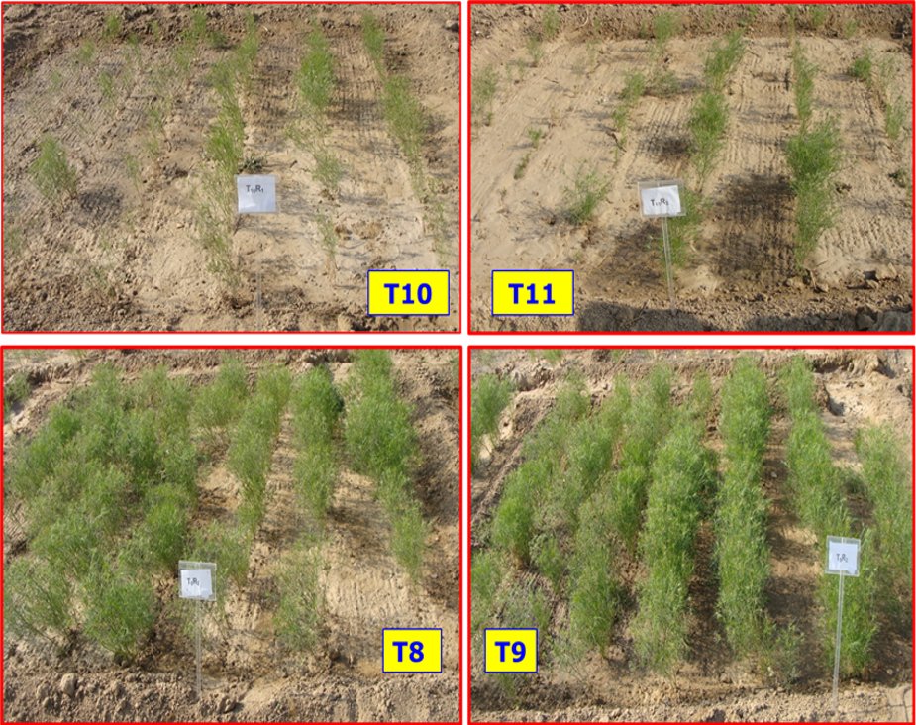
Fig.2 Sick plot view showing differences among various treatments: T8 (20DSS+T+NC), T9(30DSS+T+NC), (T10): Control, T11 (Fungicide)

A strong inverse relationship was observed between disease incidence and seed yield. The maximum seed yield (173 g plot⁻¹) was obtained from the treatment comprising 20 days of soil solarization + neem cake + T. viride, whereas the untreated control (Fig 2) produced the lowest yield (60 g plot⁻¹). The increased yield in integrated treatments can be attributed to effective pathogen suppression, resulting in improved plant establishment, reduced vascular infection, and enhanced plant growth. Integrated management practices also significantly reduced the soil pathogen population. The highest reduction in pathogen population (81.7%) was achieved with 20 days of soil solarization + neem cake + T. viride, followed by 30 days of soil solarization + neem cake + T. viride (78.9%). In comparison, the untreated control recorded only a 15.9% reduction in pathogen population. Likewise, the greatest disease reduction over the control (89.7%) was observed with 20 days of soil solarization + neem cake + T. viride, followed closely by 30 days of soil solarization + neem cake + T. viride (88.7%), whereas the untreated control showed only 16.7% disease reduction.

Table 3. Three years pooled data of cumin wilt on soil solarized plots
S.  No. | Treatment | Pathogen population (lac) /gm of soil before soil solarization | Pathogen population (lac) /gm of soil after soil solarization | Pathogen inoculum Reduction (%) | Disease incidence (%) | Reduced disease Incidence (%) | Mean soil temperature at 15 cm Depth (°C) covered soil | Seed yield  (q ha⁻¹) | CB ratio
 | SS 10 days | 10.3 | 3.9 | 63.8 | 15.43 | 71.53 | 54.49 | 7.52 | 2.10
 | SS 20 day | 11.8 | 4.0 | 72.8 | 12.27 | 76.32 | 55.29 | 8.1 | 2.14
 | SS 30 day | 8.6 | 2.9 | 76.1 | 11.20 | 77.96 | 56.86 | 8.3 | 2.30
 | SS 10-day and Trichoderma | 9.8 | 3.4 | 70.6 | 13.33 | 76.72 | 55.08 | 7.55 | 2.24
 | SS 20 day and Trichoderma | 7.3 | 2.5 | 63.1 | 10.63 | 81.02 | 55.33 | 8.12 | 2.32
 | SS 30-day and Trichoderma | 10.9 | 3.4 | 71.4 | 9.10 | 82.89 | 56.27 | 8.23 | 2.55
 | SS 10 day, Trichoderma and Neem cake | 8.0 | 2.8 | 63.9 | 8.73 | 83.89 | 53.70 | 7.68 | 2.10
 | SS 20 day, Trichoderma and Neem cake | 11.1 | 2.9 | 78.0 | 5.31 | 89.76 | 54.87 | 9.7 | 2.60
 | SS 30-day, Trichoderma and Neem cake | 22.4 | 5.2 | 82.8 | 5.69 | 88.71 | 54.83 | 10.2 | 2.77
 | Bavistin | 19.5 | 14.5 | 22.1 | 43.32 | 30.96 | 46.62 | 3.2 | 1.50
 | Control (No cover) | 16.9 | 13.7 | 15.9 | 58.81 | 16.7 | 46.32 | 2.1 | 1.77
 | SEm+  CD at 0.5% | 0.53  1.11 | 0.47  0.98 | 2.37  4.94 | 1.84  3.85 | 2.80  5.08 | 0.39  0.81 |  | 0.11  0.30

Soil solarization substantially increased soil temperature, which helped to suppress soil-borne pathogens. The maximum soil temperature (56.86°C) at a depth of 15 cm was recorded under 30 days of soil solarization, whereas the untreated control recorded the lowest temperature (46.32°C). Elevated soil temperatures during solarization are known to reduce the survival of F. oxysporum propagules directly and indirectly by enhancing the activity of beneficial antagonistic microorganisms. The incorporation of neem cake likely released fungitoxic compounds during decomposition while simultaneously improving soil health, whereas T. viride further suppressed the pathogen through mechanisms such as mycoparasitism, antibiosis, competition for nutrients and space, and induction of systemic resistance in plants. The superior performance of the integrated treatments demonstrates the synergistic interaction between physical (soil solarization), organic (neem cake), and biological (T. viride) approaches. Soil solarization reduced pathogen inoculum by exposing it to lethal temperatures, neem cake improved soil fertility while exerting antifungal effects, and T. viride established a beneficial rhizosphere that suppressed pathogen resurgence. Consequently, this integrated disease management strategy effectively minimized Fusarium wilt incidence, reduced pathogen inoculum, and significantly improved cumin productivity. These findings highlight that integrating soil solarization with neem cake and T. viride offers an eco-friendly, sustainable, and effective alternative to relying solely on chemical fungicides to manage Fusarium wilt in cumin.

Conclusion
The present study demonstrated that integrating 20 days of soil solarization with neem cake and Trichoderma viride effectively managed Fusarium wilt of cumin by significantly reducing disease incidence and soil pathogen population while increasing seed yield. The synergistic effects of physical, organic, and biological approaches provided sustainable disease suppression and improved crop productivity. This integrated strategy offers an eco-friendly, practical alternative to chemical fungicides and supports sustainable cumin cultivation. However, its performance should be validated under diverse agro-climatic conditions through multi-location and multi-season trials, along with economic evaluation and studies on long-term impacts on soil health and microbial diversity.The effectiveness of soil solarizationimproved when combined with Trichoderma viride and neem cake.It worked as a multi-target tool, managing soil-borne diseases, insect pests, and harmful weeds simultaneously.The cost-benefit ratio explains that soil solarization (BCR=2.77) is more profitable than conventional technology (BCR=1.78).
Conflict of Interest
The authors declare that they have no conflicts of interest, whether financial, personal, professional, or institutional, that could have influenced the design, execution, interpretation, or reporting of the research presented in this manuscript. All authors have reviewed and approved the final version of the manuscript and agree to its submission for publication.
Data Availability
The data that support the findings of this study are available from the corresponding author upon reasonable request. All relevant data generated or analyzed during this study are included in this published article and its supplementary materials, where applicable. Additional datasets and supporting information may be provided by the corresponding author to qualified researchers upon reasonable request, subject to institutional and ethical requirements.
Acknowledgement
The authors gratefully acknowledge the Indian Council of Agricultural Research (ICAR), New Delhi, for providing the necessary financial support, research infrastructure, laboratory facilities, and institutional resources that made the present investigation possible.
References
Anonymous. 2025. Spices Board, Govt. of India. www.Indianspices.com

Katan, J.,(1980). Solar pasteurization of soils for disease control: Status and prospects. Plant Disease, 64(5), 450–454.https://doi.org/10.1094/PD-64-450

Meena, R.D., Meena, N.L., Sharma, Y.K., Chaudhary, N., Meena, N.K., Mahatma, M.K., Meena, S.S., Saxena, S.N., Meena, M.D., Gurjar, M.S., Meena,R.S. & Vinay Bhardwaj. (2022). Aerial diseases and their management in Cuminum cyminum: A review. Int J Seed Spices.12 (1), 34-38https://doi.org/10.56093/IJSS.v12i1.3

Panse, V.G.,&Sukhatme, P.V.,(1985). Statistical Methods for Agricultural Workers. 4th Edition. Indian Council of Agricultural Research, New Delhi, India.https://krishikosh.egranth.ac.in/server/api/core/bitstreams/7603674e-2971-42d5-93d6-4935eb5e6230/content

Talaviya, J.R., I.B.,Kapadiya, C.M.,Bhaliya,& Lathiya, S.V.,(2017). Screening of Cumin Varieties/Lines against Wilt Disease. Int.J.Curr.Microbiol.App.Sci. 6(6): 3173-3176. doi: https://doi.org/10.20546/ijcmas.2017.606.373

