India's Seed Spice Exports amid Geopolitical Disruptions On-Farm Evaluation of Seed Biopriming Technology for Enhancing Germination and Seed Yield of Cumin (Cuminum cyminum L.)

https://epubs.icar.org.in/index.php/IJSS  International Journal of Seed Spices (IJSS)  Vol. 16 (1): June 2026 | 

Chetan Kumar Jangir*¹, Brijesh Kumar Mishra², Murlidhar Meena, Sanjay Kumar, Kartar Singh, Shiv Lal, Sumer Singh Meena, Shri Ram Balai, Vinay Bhardwaj

Reviewed by:  Dr. R.S. Yadav  Email: yadavrs2002@gmail.com  ICAR-Central Arid Zone Research Institute, Jodhpur, Rajasthan, India  *Correspondence:  Chetan Kumar Jangir  chetanjangir710@gmail.com  Received: 08 September 2026  Revision: 27 September 2026  Accepted: 01 October 2026  Citation:  Jangir, C.K., Mishra B.K., Meena, M., Kumar, S., Singh, K., Lal, K., Meena, S.S., Balai, S.R., Bhardwaj, V., India's Seed Spice Exports amid Geopolitical Disruptions On-Farm Evaluation of Seed Biopriming Technology for Enhancing Germination and Seed Yield of Cumin (Cuminum cyminum L.). Int J Seed Spice.16 (1): 60-66  DOI:  https://doi.org/10.56093/IJSS.v16i1.7  Affiliation:  ¹ICAR-National Research Centre on Seed Spices, Tabiji, Ajmer – 305206, Rajasthan, India  ²Indian Council of Agricultural Research, Indian Agricultural Research Institute, New Delhi, India |  | Abstract  Cumin (Cuminum cyminum L.) having small seed size, low seed vigour and poor, non-uniform field establishment, which constrains productivity in the arid and semi-arid tracts of Rajasthan. A seed-biopriming technology combining the soaking agent chitosan with a two-strain rhizobacterial consortium (Bacillus paramycoides and Pseudomonas aeruginosa) was earlier standardised and validated at the institute level. To assess its performance under real farming conditions, ten front-line demonstrations (FLDs) were conducted under SCSP on farmers' fields across seven villages of Ajmer district during the 2025 Rabi season. In each demonstration the bioprimed technology and the prevailing farmers' practice (non-bioprimed seed) were raised in adjacent, paired plots on the same field. Biopriming increased mean germination from 70.22% to 82.08% (16.9% gain) and mean seed yield from 426.0 to 516.0 kg ha⁻¹ (21.1% gain); both differences were significant (paired t-test, p < 0.01, n = 10) and every demonstration recorded higher germination and yield than its paired control. The extension gap was 90.0 kg ha⁻¹, the technology gap 12.3 kg ha⁻¹ and the technology index 2.33%, showing that farmers realised almost the full yield potential of the technology. Economic analysis showed that the bioprimed technology, at a marginal additional cost of Rs 900 ha⁻¹, raised the benefit–cost ratio from 2.24 (farmers' practice) to 2.66 and generated an additional net return of Rs 24,297 ha⁻¹, a return of Rs 28 for every rupee invested in biopriming. The on-farm yield advantage (21.1%) closely reproduced the station-level advantage (20.8%), confirming that the technology is robust and transferable. Seed biopriming with chitosan and the B. paramycoides–P. aeruginosa consortium is therefore recommended as a low-cost, profitable, and sustainable intervention to improve cumin establishment, yield, and farm income.  Keywords: front-line demonstration; seed biopriming; cumin; Bacillus paramycoides; Pseudomonas aeruginosa; technology index; benefit–cost ratio

Introduction
Cumin (Cuminum cyminum L.) is among the most important seed spices of India, valued both for domestic consumption and export, and is cultivated largely in the arid and semi-arid regions of Rajasthan and Gujarat, which together account for the bulk of national production. Despite its economic importance, cumin is characterised by diminutive seeds, an oil-rich seed coat and inherently low seed vigour, which frequently result in slow, non-uniform germination and weak crop establishment, particularly when sowing is delayed or soil moisture is limiting (Piri et al. 2019). Poor establishment directly depresses plant stand and, ultimately, seed yield, and is widely regarded as one of the principal yield-limiting factors in cumin cultivation across the Apiaceae-growing tracts of western India.

Seed priming, and biopriming in particular, has emerged as an economical and environmentally benign approach to overcome such establishment problems. Biopriming hydrates seeds in the presence of beneficial microorganisms, allowing bacterial colonisation of the seed surface while the seed is metabolically activated, and has improved germination, seedling vigour and yield in a range of crops (Ashraf and Foolad 2005; Mirshekari et al. 2012; Sarkar et al. 2021). The choice of soaking agent is integral to the process; chitosan, a natural cationic polysaccharide, forms a thin semipermeable film on the seed that regulates moisture uptake and has repeatedly enhanced germination and seedling growth (Mahdavi and Rahimi 2013). Rhizobacterial genera such as Bacillus and Pseudomonas are widely reported to promote plant growth through phytohormone production, nutrient solubilisation and rhizosphere colonisation, and their combination with a compatible soaking agent has been shown to act synergistically on germination and early vigour.

Building on this rationale, an organic biopriming technology for cumin was standardised at ICAR-National Research Centre on Seed Spices (ICAR-NRCSS), Ajmer, combining chitosan with a consortium of Bacillus paramycoides and Pseudomonas aeruginosa. Under laboratory and station field conditions this combination gave the greatest improvement in germination indices, chlorophyll content, yield attributes, seed nutrient content and soil biological health, raising station seed yield by 20.8% over the non-bioprimed control (Mishra et al. 2026). However, a technology validated on a research station does not automatically perform on heterogeneous farmers' fields, where soil type, irrigation, management skill and micro-environment vary considerably from the controlled conditions of a research farm. Front-line demonstrations (FLDs) are the established mechanism used by the Indian national agricultural research system to evaluate a proven technology under farmers' own conditions, build farmer confidence, and quantify the gap between potential and realised performance through standard extension indices (Samui et al. 2000).

In addition to agronomic performance, the economic viability of a technology ultimately determines whether resource-poor and marginal farmers will adopt it. A technology that improves yield but adds prohibitive cost, or one whose benefit–cost advantage is not demonstrated under farmers' actual cost structure, is unlikely to be adopted at scale. It is therefore essential that on-farm validation combine agronomic and economic evaluation in the same set of demonstrations.

The present study was therefore undertaken to (i) validate the chitosan–B. paramycoides–P. aeruginosa biopriming technology through front-line demonstrations on cumin growers' fields in Ajmer district; (ii) quantify its effect on germination and seed yield relative to the prevailing farmers' practice; (iii) estimate the extension gap, technology gap and technology index to judge its on-farm feasibility; and (iv) evaluate its economic performance through cost of cultivation, net return and benefit–cost ratio, to assess its readiness for wider dissemination among cumin growers.

Materials and Methods

Demonstrated technology
The technology demonstrated was organic seed biopriming using chitosan as the soaking agent together with a rhizobacterial consortium of Bacillus paramycoides and Pseudomonas aeruginosa, identified as the best-performing combination in the preceding institute-level investigation (Mishra et al. 2026). Following that protocol, cumin seeds (variety GC-4) were surface treated, soaked in the chitosan solution and then inoculated with the microbial consortium (10⁷–10⁹ cfu mL⁻¹) before shade drying prior to sowing. In the farmers' practice (control), they sowed untreated seed directly. The team prepared bioprimed seed centrally and distributed it to participating farmers before sowing.

Location, season and experimental layout
Ten front-line demonstrations were conducted under SCSP on cumin growers' fields across seven villages in Ajmer district, Rajasthan—Kesarpura, Budhwara, Brikchiyawas, Ledi, Picholiya, Mangliyawas and Tabiji (Figure 1)—during the 2025 Rabi season. In each demonstration the bioprimed technology and the farmers' practice were laid out in adjacent, paired plots on the same field, so that both treatments experienced identical soil and weather. This paired arrangement allowed a direct, within-field comparison across the ten locations and removed inter-field variability from the treatment comparison. The geographic coordinates of all ten demonstration fields were recorded by GPS (Figure 1) to document the spatial spread of the demonstrations across the district.

The recommended package of practices for cumin was followed uniformly in both plots: a seed rate of 5 kg ha⁻¹, sowing in rows 25 cm apart with 10 cm plant spacing, and consistent with the practices described by Mishra et al. (2026). Field visits were made periodically through the crop season to monitor stand establishment and crop growth (Figure 1).

Observations recorded
Germination (%) was recorded after emergence and seed yield (kg ha⁻¹) at maturity in both the bioprimed and farmers'-practice plots of every demonstration. Seedling shoot and root length (cm) were additionally measured on the bioprimed crop as the mean of five samples per field to characterise seedling vigour; a corresponding measurement was not taken in the farmers'-practice plots, so these parameters are reported descriptively for the bioprimed crop only and are not treated as a comparison.

Gap analysis
Front-line demonstration performance was summarised using the standard indices (Samui et al. 2000): the extension gap as the difference between the demonstration (bioprimed) yield and the farmers'-practice yield; the technology gap as the difference between the potential yield and the demonstration yield; and the technology index as the technology gap expressed as a percentage of the potential yield. The potential yield was taken as the seed yield achieved by the same technology under the recommended package at the research station (528.3 kg ha⁻¹; Mishra et al. 2026). A low technology index reflects better on-farm feasibility of the technology.

Economic analysis
The cost of cultivation (Rs ha⁻¹) was recorded separately for the bioprimed and farmers'-practice plots of each demonstration, covering all variable costs of production — field preparation, seed, biopriming inputs (chitosan and microbial consortium), sowing, weeding, irrigation, harvesting and threshing — based on the actual inputs used and prevailing local wage and input rates during the demonstration season. The additional cost attributable to biopriming (seed treatment material and labour) averaged Rs 900 ha⁻¹ over the farmers' practice. Gross return (Rs ha⁻¹) was calculated as seed yield multiplied by the prevailing market price of cumin (Rs 21,000 per quintal, i.e. Rs 210 kg⁻¹) during the demonstration season. Net return was obtained by subtracting the cost of cultivation from the gross return, and the benefit–cost (B:C) ratio was computed as gross return divided by cost of cultivation, for each treatment in each demonstration.

Statistical analysis
Because the two treatments were paired within each field, germination, seed yield and the economic parameters were compared between the bioprimed and farmers'-practice treatments using a paired two-tailed t-test (n = 10) for germination and yield. The percentage increase over the farmers' practice was computed from the treatment means, and results are presented as mean ± standard error unless otherwise indicated.

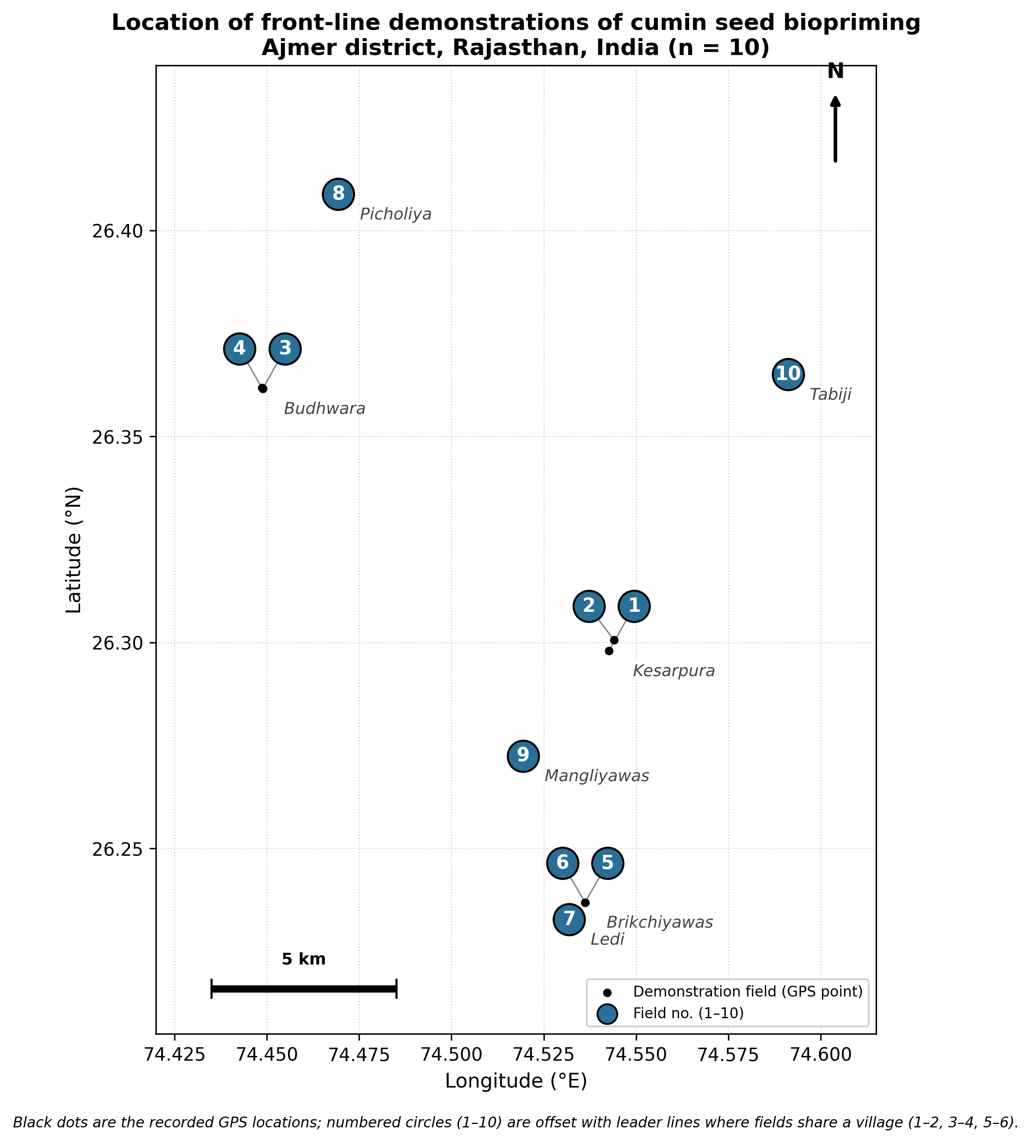

Figure 1: Blue dots are the recorded GPS locations of individual demonstration fields.

Results and Discussion

Germination
Seed biopriming markedly improved germination across the demonstrations (Table 1, Figure 2a). Mean germination under the bioprimed technology was 82.08 ± 1.58%, compared with 70.22 ± 1.48% under the farmers' practice — an increase of 16.9% that was highly significant (t = 16.19, p < 0.01). The improvement was consistent across all ten fields, ranging from 12.8% to 23.7% (Table 2). This on-farm response aligns with the germination benefit reported for the same technology at the institute level and with the established capacity of chitosan-based biopriming to accelerate and synchronise germination through regulated moisture uptake and microbial stimulation (Mahdavi and Rahimi 2013; Mishra et al. 2026). The consistent response across seven villages with differing soil and management conditions indicates that the technology's germination benefit is not confined to the controlled environment of the research station but is reproducible under the variable conditions of farmers' fields.

Seedling vigour
Seedling vigour of the bioprimed crop was characterised across the demonstrations, with a mean shoot length of 1.77 ± 0.42 cm and a mean root length of 4.55 ± 0.64 cm (Figure 3). As no corresponding measurement was made in the farmers'-practice plots, these values describe the bioprimed crop only and are not a treatment comparison; they are reported to document seedling establishment under the technology and are broadly consistent with the seedling vigour improvements reported for the same biopriming combination at the research station (Mishra et al. 2026).

Seed yield
The demonstrations produced a clear and consistent yield advantage (Table 1, Figure 2 b,c). Mean seed yield under the bioprimed technology was 516.0 ± 13.5 kg ha⁻¹ against 426.0 ± 10.5 kg ha⁻¹ under the farmers' practice, a gain of 21.1% that was highly significant (t = 15.28, p < 0.01). Every demonstration recorded a higher yield under biopriming, with field-wise gains from 17.1% to 28.8% (Table 2), underlining the reliability of the technology across differing farm conditions. Notably, this on-farm advantage of 21.1% closely matched the 20.8% advantage obtained for the same technology at the research station (Mishra et al. 2026), strongly corroborating the transferability of the biopriming package from station to field. The yield benefit is consistent with reports that biopriming enhances nutrient mobilisation, hormone production and rhizosphere colonisation, thereby supporting vegetative growth and yield formation (Madhukeshwara and Sajjan 2017; Sarkar et al. 2021).
Germination and seed yield were strongly and positively associated across the demonstrations (r = 0.99), indicating that the yield advantage was largely a downstream consequence of the improved and more uniform crop establishment achieved by biopriming, rather than an independent effect on reproductive growth.

Gap analysis
The extension gap of 90.0 kg ha⁻¹ (Table 3) represents the additional yield farmers can secure simply by adopting the biopriming technology in place of their existing practice, and points to a clear scope for wider dissemination. The technology gap was small at 12.3 kg ha⁻¹, and the technology index correspondingly low at 2.33%. A technology index of this magnitude indicates that the demonstrations realised almost the full yield potential of the technology under farmers' management, and that the package is well suited to on-farm conditions in the district with little loss between station potential and field performance. It is noted that the technology gap and technology index depend on the assumed potential yield (528.3 kg ha⁻¹, taken from the station study). If a different recommended/potential yield is adopted for the variety, these two values will change accordingly.

Economic performance
The economic evaluation confirmed that the yield advantage of seed biopriming translated into a clear and consistent financial benefit for farmers (Table 4). The mean cost of cultivation was Rs 54,907 ha⁻¹ for the bioprimed treatment and Rs 54,007 ha⁻¹ for the farmers' practice, an additional outlay of only Rs 900 ha⁻¹ for the biopriming inputs — a marginal increase of less than 2% over the farmers' existing cost structure. Against this small additional cost, the mean gross return rose from Rs 119,283 ha⁻¹ under the farmers' practice to Rs 144,480 ha⁻¹ under biopriming, a gain of Rs 25,197 ha⁻¹ (21.1%), mirroring the yield increase reported above.
Consequently, the mean net return from the bioprimed technology was Rs 89,573 ha⁻¹, compared with Rs 65,276 ha⁻¹ from the farmers' practice — an additional net return of Rs 24,297 ha⁻¹. The benefit–cost ratio improved from 2.24 under the farmers' practice to 2.66 under biopriming, an improvement of 18.9%, and this advantage held across every demonstration, with the bioprimed B:C ratio ranging from 2.14 to 3.09 against 1.84 to 2.67 for the farmers' practice (Table 4). Expressed as a return on the biopriming investment specifically, the additional gross return of Rs 25,197 ha⁻¹ against an additional cost of Rs 900 ha⁻¹ represents a marginal return of approximately Rs 28 for every rupee invested in biopriming — an exceptionally favourable ratio that reflects the very low cost of the seed-treatment inputs relative to the value of the yield gain they generate.
These results indicate that seed biopriming is not only agronomically effective but also economically attractive and low-risk for adoption. Because the additional investment required is small in absolute terms (Rs 900 ha⁻¹) relative to the overall cost of cumin cultivation, the technology is accessible even to small and marginal farmers with limited capital, and the consistency of the B:C improvement across all ten demonstrations — spanning seven villages with differing soil and management conditions — suggests that the economic benefit is robust rather than dependent on especially favourable individual sites. This combination of low cost, low risk and high marginal return is a strong basis for recommending the technology for wider extension in the district.

Table 1. Effect of seed biopriming on germination and seed yield of cumin under front-line demonstrations (n = 10).
Parameter | Bioprimed (Mean ± SE) | Farmers' practice (Mean ± SE) | Increase (%) | t value | p value
Germination (%) | 82.08 ± 1.58 | 70.22 ± 1.48 | 16.9 | 16.19 | < 0.01
Seed yield (kg ha⁻¹) | 516.00 ± 13.45 | 426.01 ± 10.47 | 21.1 | 15.28 | < 0.01

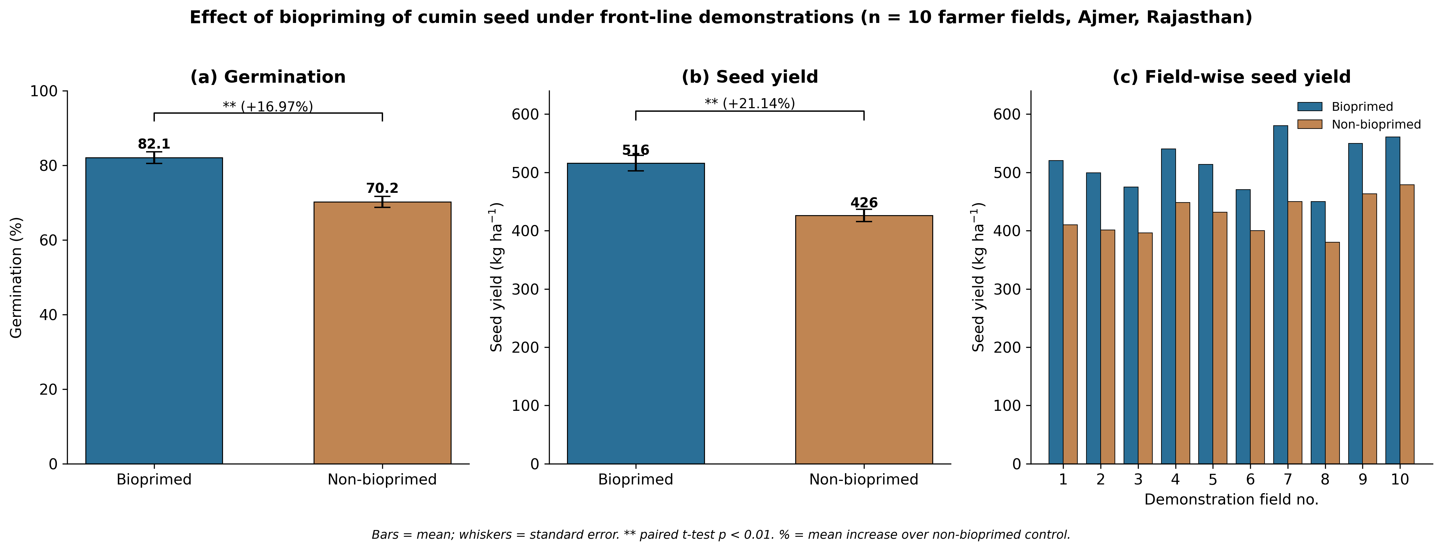
Figure 2. Germination (a) and seed yield (b) under the bioprimed technology versus farmers' practice, and field-wise seed yield (c). Bars = mean; whiskers = standard error; ** p < 0.01. BP = bioprimed technology; FP = farmers' practice (non-bioprimed).
Table 2. Field-wise germination and seed yield with percentage increase over the farmers' practice.
Field | Village | Germ. BP (%) | Germ. FP (%) | Germ. incr. (%) | Yield BP | Yield FP | Yield incr. (%)
1 | Kesarpura | 83.1 | 73.5 | 13.1 | 520.5 | 410.0 | 27.0
2 | Kesarpura | 81.0 | 71.8 | 12.8 | 499.3 | 401.4 | 24.4
3 | Budhwara | 78.4 | 67.3 | 16.5 | 474.9 | 396.1 | 19.9
4 | Budhwara | 84.6 | 69.7 | 21.4 | 540.3 | 448.2 | 20.5
5 | Brikchiyawas | 81.5 | 68.9 | 18.3 | 513.5 | 431.7 | 18.9
6 | Brikchiyawas | 77.1 | 66.1 | 16.6 | 470.3 | 400.0 | 17.6
7 | Ledi | 89.2 | 77.8 | 14.7 | 580.0 | 450.2 | 28.8
8 | Picholiya | 72.8 | 61.6 | 18.2 | 450.2 | 380.1 | 18.4
9 | Mangliyawas | 86.0 | 75.1 | 14.5 | 550.0 | 463.4 | 18.7
10 | Tabiji | 87.1 | 70.4 | 23.7 | 561.0 | 479.0 | 17.1
Mean |  | 82.1 | 70.2 | 17.0 | 516.0 | 426.0 | 21.1
Table 3. Front-line demonstration gap analysis for cumin seed yield.

Parameter | Value
Demonstration (bioprimed) yield | 516.0 kg ha⁻¹
Farmers' practice yield | 426.0 kg ha⁻¹
Potential yield (station package; Mishra et al. 2026) | 528.3 kg ha⁻¹
Extension gap | 90.0 kg ha⁻¹
Technology gap | 12.3 kg ha⁻¹
Technology index | 2.33 %
Additional yield over farmers' practice | 21.1 %

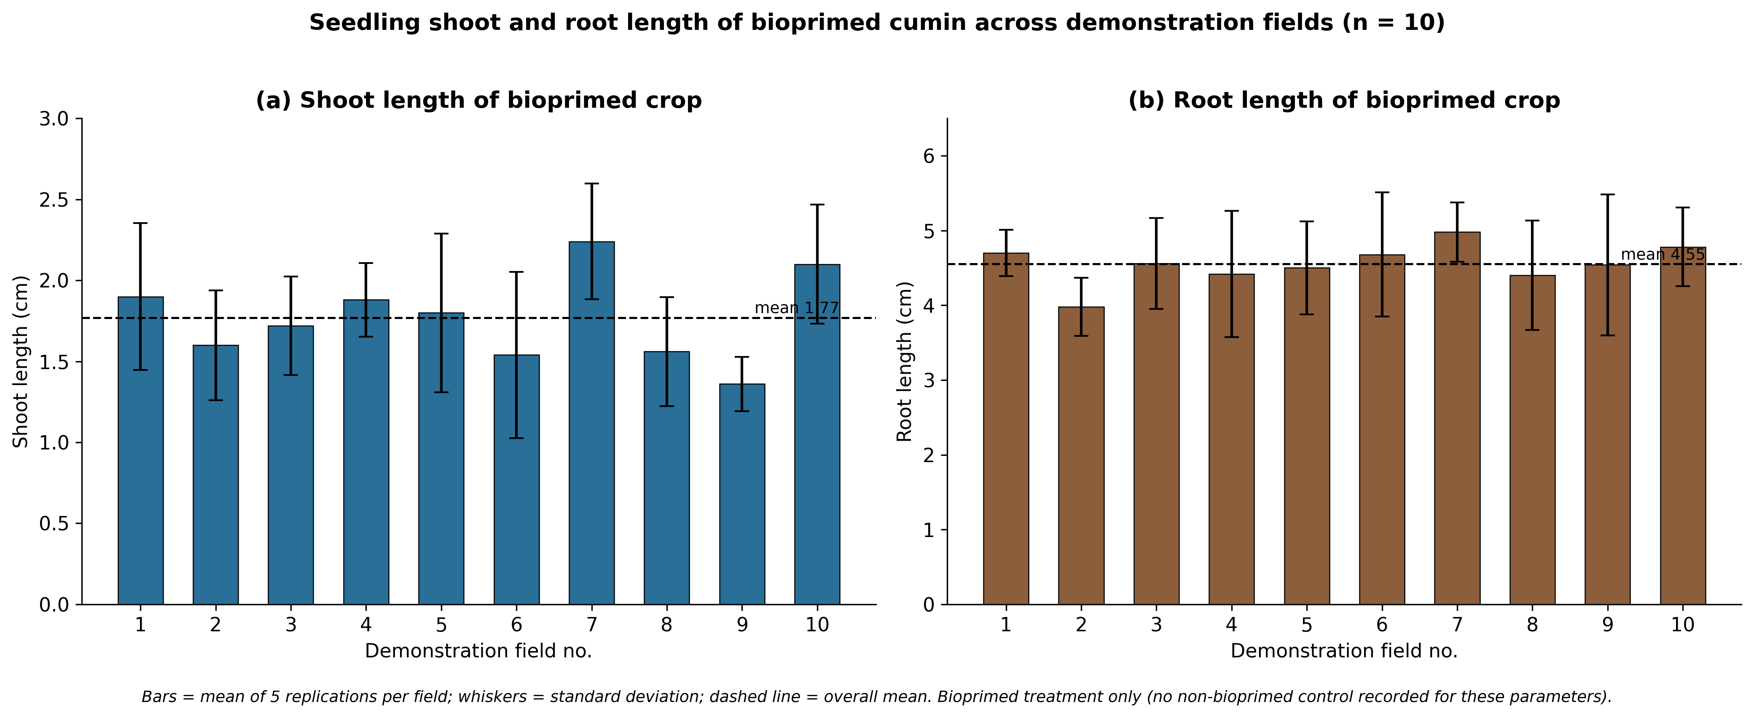

Figure 3. Seedling shoot (a) and root (b) length of the bioprimed cumin crop across demonstrations. Bars = mean of five samples per field; whiskers = standard deviation; dashed line = overall mean. Bioprimed crop only — descriptive, not a comparison.

Table 4. Field-wise economic performance of cumin seed biopriming technology (n = 10). Cost BP/FP = cost of cultivation (Rs ha⁻¹) under bioprimed / farmers'-practice treatment; Gross BP/FP = gross return (Rs ha⁻¹), computed at Rs 210 kg⁻¹; Net BP/FP = net return (Rs ha⁻¹); B:C BP/FP = benefit–cost ratio. Mean row values are treatment means across the ten demonstrations.
Field | Village | Cost BP (Rs/ha) | Cost FP (Rs/ha) | Gross BP (Rs/ha) | Gross FP (Rs/ha) | Net BP (Rs/ha) | Net FP (Rs/ha) | B:C BP | B:C FP
1 | Kesarpura | 62443 | 61543 | 145740 | 114800 | 83297 | 53257 | 2.33 | 1.87
2 | Kesarpura | 57338 | 56438 | 139804 | 112392 | 82466 | 55954 | 2.44 | 1.99
3 | Budhwara | 50658 | 49758 | 132972 | 110908 | 82314 | 61150 | 2.62 | 2.23
4 | Budhwara | 56573 | 55673 | 151284 | 125496 | 94711 | 69823 | 2.67 | 2.25
5 | Brikchiyawas | 58731 | 57831 | 143780 | 120876 | 85049 | 63045 | 2.45 | 2.09
6 | Brikchiyawas | 61665 | 60765 | 131684 | 112000 | 70019 | 51235 | 2.14 | 1.84
7 | Ledi | 56777 | 55877 | 162400 | 126056 | 105623 | 70179 | 2.86 | 2.26
8 | Picholiya | 40776 | 39876 | 126056 | 106428 | 85280 | 66552 | 3.09 | 2.67
9 | Mangliyawas | 49800 | 48900 | 154000 | 129752 | 104200 | 80852 | 3.09 | 2.65
10 | Tabiji | 54311 | 53411 | 157080 | 134120 | 102769 | 80709 | 2.89 | 2.51
Mean |  | 54907 | 54007 | 144480 | 119283 | 89573 | 65276 | 2.66 | 2.24

Conclusion
Front-line demonstrations on ten farmers' fields across seven villages of Ajmer district confirmed that seed biopriming with chitosan and a Bacillus paramycoides–Pseudomonas aeruginosa consortium substantially improves cumin performance under real farming conditions. The technology raised germination by 16.9% and seed yield by 21.1% over the prevailing farmers' practice, with a significant and uniform response across all locations, an extension gap of 90 kg ha⁻¹ and a low technology index of 2.33%; the close agreement between the on-farm and station-level yield advantages demonstrates that the technology is robust and readily transferable. Economically, the technology required only a marginal additional investment of Rs 900 ha⁻¹ yet raised the benefit–cost ratio from 2.24 to 2.66 and delivered an additional net return of Rs 24,297 ha⁻¹, with a return of roughly Rs 28.00 for every rupee invested in biopriming. Seed biopriming can therefore be recommended as a low-cost, low-risk, organic and profitable intervention for improving cumin establishment, yield and farm income in Ajmer and comparable arid and semi-arid cumin-growing tracts. Given its consistent performance and favourable economics across diverse farm conditions, wider dissemination of this technology through state agricultural extension machinery and farmer-producer organisations is recommended. Demonstration over additional seasons and agro-climatic zones would further strengthen the evidence base for large-scale adoption.
Acknowledgement
The authors gratefully acknowledge the Indian Council of Agricultural Research (ICAR) and ICAR-National Research Centre on Seed Spices (ICAR-NRCSS), Ajmer, for institutional support and the Scheduled Caste Sub-Plan (SCSP) cell of ICAR-NRCSS for funding and coordinating the front line demonstration. The authors also thank the participating SC farmers of Ajmer district, Rajasthan, for their cooperation in field demonstration and post-harvest data collection of cumin during the 2025–26 season.
Declaration of interest statement
The authors declare that there is no conflict of interest associated with this publication.

References
Ashraf, M., Foolad, M.R., (2005). Pre-sowing seed treatment—a shotgun approach to improve germination, plant growth, and crop yield under saline and non-saline conditions. Adv Agron. 88:223–271.
Madhukeshwara, B.P., Sajjan, A.S., (2017). Influence of bio-priming on field performance and yield in maize hybrid. Acta Sci Agric. 1(1):16–19.
Mahdavi, B., Rahimi, A., (2013). Seed priming with chitosan improves the germination and growth performance of ajowan. Eurasian J Biosci. 7:69–76.
Mirshekari, B., Hokmalipour, S., Sharifi, R.S., (2012). Effect of seed biopriming with plant growth promoting rhizobacteria (PGPR) on yield and dry matter accumulation of spring barley. J Food Agric Environ. 10:314–320.
Mishra, B.K., Jangir, C.K., Saxena, S.N., Sharma, Y.K., Kant, K., Mahatma, M.K., Bhardwaj, V., (2026). Improving seed germination indices and yield in cumin through organic biopriming with microbial consortia and soaking agents: laboratory and field investigations. Biol Agric Hortic. doi:10.1080/01448765.2026.2635965.
Piri, R., Moradi, A., Balouchi, H., Salehi, A., (2019). Improvement of cumin (Cuminum cyminum) seed performance under drought stress by seed coating and biopriming. Sci Hortic. 257:108667.
Samui, S.K., Maitra, S., Roy, D.K., Mandal, A.K., Saha, D., (2000). Evaluation of front line demonstration on groundnut. J Indian Soc Coastal Agric Res. 18(2):180–183.
Sarkar, D., Singh, S., Parihar, M., Rakshit, A., (2021). Seed bio-priming with microbial inoculants: a tailored approach towards improved crop performance, nutritional security and agricultural sustainability for smallholder farmers. Curr Res Environ Sustain. 3:100093.

