Medical Management of Grey Slender Loris with Tonic Clonic Seizures – A Case Report

Navaz Shariff* and H.V.Madhav
People for Animals Bengaluru, 67, Uttarahalli Main Road, Kengeri, Bengaluru-560060
*gm@peopleforanimalsbangalore.org
Received: July 2024 153/24 Accepted: January 2025

ABSTRACT
An adult male Slender Loris weighing 230 g was rescued, which was found recumbent on the ground. On observation and physical examination, it was noticed that the animal had tonic-clonic seizures every 30 mins and each episode lasted for 4-5 seconds. The animal was treated with inj. diazepam and oral homoeopathic medication. The animal was fed with a homemade feeding formula and glucose solution. The animal was observed for 36 hours after treatment, during which it showed no recurrence of seizures, and then it was released back into the wild.
Keywords: Gray SlenderLoris, Tonic-clonic seizures, Homoeopathic medication
INTRODUCTION
The Grey Slender Loris, Loris lydekkerianus, is a small, nocturnal prosimian endemic to the southern peninsular region of India and Sri Lanka (Nekaris& Jayewardene, 2003). There are two subspecies of Slender Lorises in India, namely the Mysore Slender Loris, Loris lydekkerianuslydekkerainus and the Malabar Slender Loris, Loris lydekkerianus malabaricus, found in the Eastern and Western ghats, respectively (Kumara et al., 2016). In the wild, Slender Lorises primarily forage on a wide variety of insects, especially ants and termites (Nekaris and Rasmussen, 2003; Kumara et al., 2005).
As per the IUCN Red List Assessment (2020), the Grey Slender Loris, previously under the category of least concern, is now categorized as near threatened, and this reduction in Loris population is mainly attributed to habitat loss and/or hunting practices. In India, these animals are illegally kept captive and used for the preparation of traditional medicines and black magic practices, which further adds to the decline in their population (Gnanaolivu et al., 2022).
This case report describes the treatment and release of a Gray Slender Loris which was presented with a history of seizures.
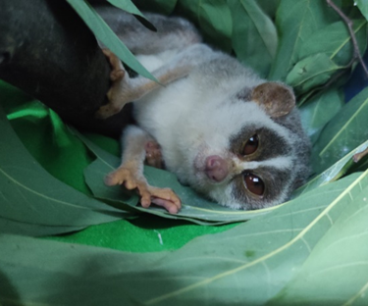
Fig 1. Slender Loris having seizures
MATERIALS AND METHODS
An adult, male Grey Slender Loris was presented to People for Animals, Bengaluru Wildlife Hospital with a history of seizures. The animal was found fallen on the ground and immobile (Fig. 2).
It was taken to the DCF (urban) and later transferred to PFA for treatment. Complete physical examination revealed no gross abnormalities.
The animal weighed 230 grams and presented with tonic-clonic seizures (Fig 1) every 30 minutes. Each episode lasted for 4-5 seconds, and two such episodes were recorded. The animal was under a lot of stress due to which it could have suffered capture myopathy, and hence confirmatory diagnosis was not performed, and palliative treatment was considered.
The animal was treated with Inj. Diazepam (LORI®) @ 0.5 mg/kg BW (James & Craig, 2022) intramuscularly to Control the seizures and Suspension Meloxicam (MeloneX®) @ 0.2 mg/kg (James & Craig, 2022) orally for once daily for two days. Homeopathic drops Hypericum @ 2 drops daily was also given (Fig 3). Hand feeding was done with glucose solution, handmade feeding formula and super worms.
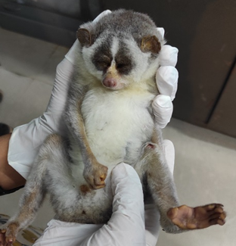
Fig 2. Slender Loris rescued immobile

The animal was kept under observation for 36 hours after treatment, during which it showed no recurrence of seizures (Fig 4). The animal was deemed fit and released back into the same habitat.
RESULTS AND DISCUSSION
Seizures in animals are clinically manifested as altered or loss of consciousness, altered behaviour, tonic-clonic movements and incontinence with sudden onset and cessation (Blatt et al., 2017; Berendt et al., 2015). Although there are no known reports of seizures in wild Grey Slender Lorises, reports of epileptic seizures and their treatment have been recorded in other wild/captive animals (IWATA, 1998; Blatt et al., 2017; Simeone et al., 2022)
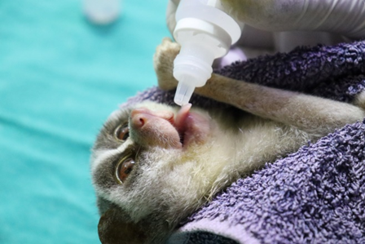
Fig 3. Slender Loris treated with homeopathic medicine: Hypericum

Baroni & Poli (2015) described the use of benzodiazepines such as diazepam and midazolam as the first pharmacological action to control epileptic seizures in animals. In the present case, diazepam was administered for its anticonvulsant action and showed positive results in the Gray Slender Loris. There is a lack of veterinary literature describing the dose of diazepam and meloxicam in prosimians, and therefore dosing was based on that used in primates as described by James and Craig (2022). This is the first report on the successful treatment of a Gray Slender Loris with seizures and its release into the wild. The case describes the use of diazepam for seizures and further promotes research on the use and dose of the drug in other wild species.
ACKNOWLEDGEMENT
The authors thank all the staff at PfA Wildlife Hospital for their expertise in handling animals, Rahul J and Vasanth R for rehabilitation and Anand B for rescuing the animal.
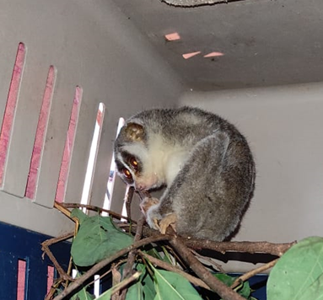Fig 4. Slender Loris recovered after treatment

REFERENCES
Nekaris, K.A.I. and J.Jayewardene (2003), Pilot study and conservation status of the Slender Loris (Loris tardigradus and L. lydekkerianus) in Sri Lanka, Primate Conservation, 19: 83-90.
Kumara, H.N., R.Sasi, S.Chandran and S.Radhakrishna (2016), Distribution of the grey Slender Loris (Loris lyddekerianus Cabrera, 1908) in Tamil Nadu, southern India, Folia Primatologica, 87(5): 291-302.
Nekaris, K.A.I. and D.T.Rasmussen (2003), Diet and feeding behavior of Mysore Slender Lorises, International Journal of Primatology, 24: 33-46.
Kumara, H.N., S.Kumar and M.Singh (2005), A novel foraging technique observed in Slender Loris (Loris lydekkerianus malabaricus) feeding on red ants in the Western Ghats, India, Folia Primatologica, 76(2): 116-118.
Dittus, W., M.Singh, S.N.Gamage, H.N.Kumara, A.Kumar and K.A.I.Nekaris (2022), Loris lydekkerianus (amended version of 2020 assessment). The IUCN Red List of Threatened Species 2022: e.T44722A217741551. https://dx.doi.org/10.2305/IUCN.UK.20221.RLTS.T44722A217741551.en. Accessed on 23 September 2023.
Gnanaolivu, S.D., M.Campera, K.A.I.Nekaris, V.Nijman, R.Satish, S.Babu and M.Singh (2022), Medicine, black magic and supernatural beings: Cultural rituals as a significant threat to Slender Lorises in India, People and Nature, 4(4): 1007-1019.
Blatt, E.R., K.E.Seeley, M.C.Lovett and R.E.Junge (2017), Management of a reeve's muntjac (Muntiacus reevesi) with seizures using levetiracetam, Journal of Zoo and Wildlife Medicine, 48(4): 1197-1199.
Berendt, M., R.G.Farquhar, P.J.Mandigers, A.Pakozdy, S.F.Bhatti, L.De Risio, ... and H.A.Volk (2015), International veterinary epilepsy task force consensus report on epilepsy definition, classification and terminology in companion animals, BMC Veterinary Research, 11(1): 1-11.
IWATA, E. (1998), Epilepsy Suspected Seizure and Control in California Sea Lion (Zαlophus cαliforniαnus), Japanese Society of Zoo and Wildlife Medicine, 3(1): 59-63.
Simeone, C.A., J.P.Andrews, S.P.Johnson, M.Casalia, R.Kochanski, E.F.Chang and S.C.Baraban (2022), Xenotransplantation of porcine progenitor cells in an epileptic California Sea lion (Zalophus californianus): illustrative case, Journal of Neurosurgery: Case Lessons, 3(12).
Baroni, M., and F.Poli (2015), Status Epilepticus: a clinical approach, Veterinaria (Cremona), 29(1): 37-45.
James, W.C. and A.H.Craig (2022), Carpenter’s Exotic Animal Formulary, 6, 702.

